INTERNSHIP PROJECT REPORT ON

“**BUILDING E-COMMERCE WEBSITE**

**ON SHOPIFY PLATFORM**”

## Submitted

*In the partial fulfilment of the requirements for*

*The award of the degree of*

**BACHELOR OF TECHNOLOGY**

In

## COMPUTER SCIENCE & ENGINEERING

By

Rama Krishna Kamma (161FA04300)

Pavan Kumar Bandarupalli (161FA04283)

Rama Kishore Manikonda (161FA04456)

Under the guidance of

**Ms. Sajida Sultana**, Assistant Professor



**DEPARTMENT OF COMPUTER SCIENCE & ENGINEERING**

**VIGNAN'S FOUNDATION FOR SCIENCE, TECHNOLOGY AND RESEARCH Deemed to be UNIVERSITY Vadlamudi, Guntur.**

INTERNSHIP PROJECT REPORT ON

“**BUILDING E-COMMERCE WEBSITE**

**ON SHOPIFY PLATFORM**”

### Submitted

*In the partial fulfilment of the requirements for*

*The award of the degree of*

**BACHELOR OF TECHNOLOGY**

In

### COMPUTER SCIENCE & ENGINEERING

By

Rama Krishna Kamma (161FA04300)

Pavan Kumar Bandarupalli (161FA04283)

Rama Kishore Manikonda (161FA04456)

Under the guidance of

**Ms. Sajida Sultana**, Assistant Professor



**DEPARTMENT OF COMPUTER SCIENCE & ENGINEERING**

**VIGNAN'S FOUNDATION FOR SCIENCE, TECHNOLOGY AND RESEARCH Deemed to be UNIVERSITY Vadlamudi, Guntur.**

**VIGNAN’S FOUNDATION FOR SCIENCE TECHNOLOGY AND**

**RESEARCH Deemed to be UNIVERSITY**

VADLAMUDI, GUNTUR DIST, ANDHRA PRADESH, INDIA, PIN-522 213



**CERTIFICATE**

This is to certify that the Internship Report entitled **“BUILDING OF E-** **COMMERCE WEBSITE ON SHOPIFY PLATFORM”** that is being submitted by **Rama Krishna Kamma (161FA04300), Pavan Kumar Bandarupalli (161FA04283), Rama Kishore Manikonda (161FA04456)** in partial fulfilment for the award of B.Tech degree in Computer Science and Engineering to the Vignan’s Foundation for Science, Technology and Research, Deemed to be University, is a record of bonafide work carried out by them at **Urbanjet Hospitality Services Pvt.Ltd.** under the supervision of **Mr. Inamala Chanukya** under the co-guidance of the following faculty member of CSE Department.

Ms.Sajida Sultana External Examiner Dr.Venkatesulu Dondeti

Assistant Professor HOD, CSE

## 

## DECLARATION

I hereby declare that the project entitled **“DEVELOPMENT OF E-COMMERCE WEBSITE ON SHOPIFY PLATFORM”** submitted for the **DEPARTMENT OF COMPUTER SCIENCE AND ENGINEERING.** This dissertation is our original work and the project has not formed the basis for the award of any degree, associate-ship and fellowship or any other similar titles and no part of it has been published or sent for publication at the time of submission.

By

Rama Krishna Kamma (161FA04300)

Pavan Kumar Bandarupalli (161FA04283)

Rama Kishore Manikonda (161FA04456)

Date:

## ACKNOWLEDGEMENT

Internship program is a golden opportunity for learning and self-development. Consider myself very lucky and honored to have so many wonderful people lead me through in the completion of this project.

I express my gratitude towards the Managing Director of **URBANJET HOSPITALITY SERVICES PVT. LTD., Mr. Inamala Chanukya** for permitting me to undertake the **Internship Program** in their esteemed company and for the help and cooperation throughout the course of my Internship Program.

I feel it my responsibility to thank **Ms. Sajida Sultana** under whose valuable guidance that the project came out successfully after each stage, and also it is my responsibility to extend my thanks to **Mr.D.Yakobu**, **Department Internship Coordinator** and extending his support towards the Internship Program in **UBANJET HOSPITALITY SERVICES PVT LTD., HYDERABAD.**

It is a great pleasure for me to express my sincere thanks to **Dr. Venkatesulu Dondeti, HOD, CSE** of VFSTR Deemed to be University**,** for providing me an opportunity to do my Internship Program.

It is my pleasure to extend my sincere thanks to our Dean Training & Management, **Mr.D.Vijaya krishna,** for providing me an opportunity to do our internship program in **URBANJET HOSPITALITY SERVICES PVT.LTD, HYDERABAD.**

I extend my whole hearted gratitude to all my faculty members of Department of Computer Science and Engineering who helped me in my academics throughout this course.

Finally I wish to express thanks to my family members for the love and affection overseen and forbearance and cheerful depositions, which are vital for sustaining effort, required for completing this work.

With Sincere regards,

Rama Krishna Kamma (161FA04300)

Pavan Kumar Bandarupalli (161FA04283)

Rama Kishore Manikonda (161FA04456)

## 

## Table of Contents

CONTENTS………............................................................................................................6

LIST OF FIGURES.............................................................................................................8

ABBREVIATIONS ..........................................................................................................10

INTERNSHIP SUMMARY… .........................................................................................11

PROFILE OF COMPANY ...............................................................................................12

ABSTRACT ......................................................................................................................13

1. INTRODUCTION ....................................................................................................... 14

* 1. Introduction ........................................................................................................15
  2. Advantages of Using Shopify ........................................................................... 15
  3. What is Shopify Platform? ............................................................................... 16
  4. What is SaaS? ...................................................................................................16
  5. What is Shopify template? ................................................................................16
  6. Account Plans in Shopify ..................................................................................16

2. SOFTWARE REQUIREMENTS SPECIFICATION .................................................17

* 1. Requirement Analysis .......................................................................................18
  2. Problem Statement ........................................................................................... 18
  3. Functional Requirements ..................................................................................18
  4. Software Requirement Specification ...............................................................20
  5. Software Requirements .................................................................................. 21
  6. Hardware Requirements...................................................................................21
  7. Non-Functional Requirements ........................................................................21
  8. Feasibility study ..............................................................................................22

3. ANALYSIS & DESIGN ...........................................................................................23

* 1. Introduction .................................................................................................... 24
  2. System Overview ........................................................................................... 25
  3. Action of a theme in shopify ...........................................................................29
  4. General settings of theme in Shopify ............................................................. 29
  5. Customizing theme in Shopify ....................................................................... 30
  6. Customizing sections ..................................................................................... 31

4. MODELING ............................................................................................................ 32

* 1. Modelling ....................................................................................................... 33
  2. UML Modelling diagrams .............................................................................. 34
  3. ER Diagram .................................................................................................... 45

5. IMPLEMENTATION ............................................................................................................. 46

* 1. Introduction to Implementation ............................... .......................................47
  2. Introduction to liquid .......................................................................................47
  3. Code organization on Shopify platform ......................................................... 48
  4. Getting started with theme development ........................................................ 49
  5. Sample Code ................................................................................................... 49
  6. Screenshots ..................................................................................................... 56

6. TESTING................................................................................................................................ 77

* 1. Software Testing ............................................................................................. 78
  2. Black box Testing ........................................................................................... 78
  3. White box Testing.........................................................................................…78
  4. Performance Testing ........................................................................................78
  5. Load Testing ....................................................................................................78
  6. Manual Testing ............................................................................................... 78

7. RESULTS AND CHALLENGES……..................................................................... 81

* 1. Results ............................................................................................................ 82
  2. Challenges ...................................................................................................... 82

8. CONCLUSION ....................................................................................................... 83

* 1. Conclusion ...................................................................................................... 84
  2. Scope for future work ..................................................................................... 84
  3. Limitations ...................................................................................................... 84

BIBLIOGRAPHY ..........................................................................................................85

|  |  |  |  |  |  |
| --- | --- | --- | --- | --- | --- |
|  | | **List of Figures** |  | | |
| Fig 3.1 | | Subscribe to Shopify | 25 | | |
| Fig 3.2 | | Creating Store in Shopify | 26 | | |
| Fig 3.3 | | Registering to Shopify | 27 | | |
| Fig 3.4 | | Homepage of Shopify | 28 | | |
| Fig 3.5 | | Themes of Shopify | 28 | | |
| Fig 3.6 | | Actions of theme | 29 | | |
| Fig 3.7 | | Color Settings | 30 | | |
| Fig 3.8 | | Topography options | 30 | | |
| Fig 3.9 | | Favicon | 31 | | |
| Fig 3.10 | | Checkout settings | 31 | | |
| Fig 3.11 | | Theme overview | 32 | | |
| Fig 3.12 | | Theme editor | 32 | | |
| Fig 4.1 | | Use case diagram for the system | 36 | | |
| Fig 4.2 | | Sequence diagram for customers | 38 | | |
| Fig 4.3 | | Sequence diagram for entire system | 39 | | |
| Fig 4.4 | | Activity diagram for e-commerce order process | 41 | | |
| Fig 4.5 | | Activity diagram for entire system | 42 | | |
| Fig 4.6 | | Class diagram for online Shopping | 44 | | |
| Fig 4.7 | | ER diagram | 45 | | |
| Fig 5.1 | | Code organization | 48 | | |
| Fig 5.2 | | Shopify partner dashboard | 49 | | |
| Fig 5.3 | | Grid Banner | 57 | | |
| Fig 5.4 | | Strip Banner | 57 | | |
| Fig 5.5 | | Navigation | 58 | | |
| Fig 5.6 | | Newsletter | 58 | | |
| Fig 5.7 | | Footer Section | 59 | | |
| Fig 5.8 | | Slideshow | 59 | | |
| Fig 6.1 | Test case for empty login fields | | 79 |
| Fig 6.2 | Test case for wrong login fields | | 80 |

#### 

#### ABBREVIATIONS

* API : APPLICATION PROGRAMMING INTERFACE
* UI : USER INTERFACE
* JSON : JAVA SCRIPT OBJECT NOTATION
* IDE : INTEGRATED DEVELOPMENT ENVIRONMENT
* HTML : HYPER TEXT MARKUP LANGUAGE
* SaaS : SOFTWARE AS A SERVICE
* CSS : CASCADING STYLE SHEETS
* JS : JAVASCRIPT
* SCSS : SASSY CSS
* SASS : SYNTACTICALLY AWESOME STYLE SHEET
* POS : POINT OF SALE
* SEO : SEARCH ENGINE OPTIMIZATION
* CSV : COMMA SEPARATED VALUES
* URL : UNIFORM RESOURCE LOCATOR
* SDD : SOFTWARE DESIGN DESCRIPTION
* POS ; POINT OF SALE

#### INTERNSHIP SUMMARY

**Location :** Hyderabad

**Organization :** Urbanjet Hospitality Services Pvt. Ltd.

**Duration :** 5 Months**.**

**Date of start :** 16th December, 2019.

**Date of submission :** 29th April, 2020.

**Title of project :** BUILDING OF E-COMMERCE WEBSITE ON

##### SHOPIFY PLATFORM.

**Team Members :** K Ramakrishna (161FA04300), B Pavan Kumar

(161FA0283), M Ram Kishore (161FA04456).

**Name of the guide :** Mr.Inamala Chanukya, Chief Executive Officer, Urbanjet

Hospitality Services Pvt. Ltd, Hyderabad.

**Name of faculty guide :** Ms. Sajida Sultana, Assistant Professor, VFSTR Deemed to be

University.

**Project Area :** E-Commerce Websites Development.

**Abstract :** The current project is associated with website development for

building online stores using Shopify platform. With the help of outcome of these project, the merchants can easily design, develop and deploy their online stores with minimum effort and at reasonable cost with maximum profit potential. As this project is developed on Shopify platform which is a global level platform, the store owners can sell their products to customers from foreign countries. Hence, it helps in globalization of businesses.

#### Signature of Student Signature of Faculty Guide

**Date: Date:**

## PROFILE OF THE COMPANY

### Our story

UrbanJet Hospitality Services Pvt Ltd was started as a way to provide corporate-level support and services to small businesses and individual clients. We started out as a small online shop, but with the constantly expanding customer base, managing our company was becoming increasingly difficult. The more the business expanded, the harder it got to provide each and every one of our customers with the individual attention they deserved. After a series of bad experiences with online staff for hire, we decided it was time to transform the world of small business. We founded UrbanJet Hospitality Services in 2018 to provide the level of services and support big corporations possess - without having to pay a fortune for it. Hiring online staff can be a low cost option, but it’s rarely a reliable long-term solution. We at UrbanJet Hospitality Services want to change the way you run your business and help you successfully manage your team, grow your customer base and expand your reach.

### Our Mission

We believe in helping startups grow globally and help companies reach their customers in an affordable but effective way. We are dedicated to provide low cost and reliable 24/7 support, so you can successfully manage your business and drive your company to success. UrbanJet Hospitality Services was founded to provide small businesses with the same level of support and marketing services big corporations enjoy. We are extremely passionate about what we do and we believe in working for, as well as with our clients. Regardless of your business goals or current requirements, we strive to offer creative and custom-tailored solutions and ongoing support, so you can effectively expand your business and develop your personal brand.

**Address:**

703, Manjeera Majestic Commercial,

Kukatpally,

Hyderabad 500085,

Telangana, India, +91 4067231943

## ABSTRACT

The current project is associated with website development for building online stores using Shopify platform. With the help of outcome of these project, the merchants can easily design, develop and deploy their online stores with minimum effort and at reasonable cost with maximum profit potential.

As this project is developed on Shopify platform which is a global level platform, the store owners can sell their products to customers from foreign countries. Hence, it helps in globalization of businesses.

Shopify enables you to create powerful ecommerce solutions for a variety of scenarios, including integrating your service into the Shopify admin, customizing any website, and more.

Shopify’s APIs let developers integrate with the platform in a variety of ways. Depending on the purpose of your app, you’ll first need to choose whether it will be public or private. Public apps are meant for developers who want to distribute their apps to many merchants. Private apps are meant for developers building an app for a single merchant or a small group of clients.

**CHAPTER – 1**

**INTRODUCTION**

# 

# INTRODUCTION

## 1.1 Introduction

Most shop owners don’t want the hassle of building a website from scratch and maintaining the tricky mechanics. They just want to sell. That’s where Shopify comes in Shopify is a [Canadian](https://en.wikipedia.org/wiki/Economy_of_Canada) [e- commerce](https://en.wikipedia.org/wiki/Economy_of_Canada) [c](https://en.wikipedia.org/wiki/Economy_of_Canada)ompany. It is also the name of its proprietary e- commerce platform for online stores and [retail point-of-sale](https://en.wikipedia.org/wiki/Retail) [s](https://en.wikipedia.org/wiki/Retail)ystems.

Shopify provides you with a variety of tools to help you to set up and run your business. Depending on [the pricing plan t](https://www.shopify.com/pricing)hat you choose, you can find everything you need to showcase your products online, to process payments, and to make your store work for you.

With Shopify you can sell products in different ways using many sales channels. Although you're not limited to choosing only one way to sell, it's important to have an idea of your business requirements so you can choose a [pricing plan](https://www.shopify.com/pricing) that works for you. Depending on the type of business you are running and the [way you want to sell y](https://help.shopify.com/manual/intro-to-shopify/overview#ways-to-sell)our products, your needs might vary. Because of this, Shopify offers several subscription plans that have different monthly fees, transaction fees, and store features.

Shopify offers many resources to help you succeed. In addition to the Help Centre, you can find guides and tutorials about growing your business in the [Shopify community.](https://help.shopify.com/manual/intro-to-shopify/overview#community) If you can't figure out how to do something on your own, then you can [ask Support,](https://help.shopify.com/manual/intro-to-shopify/overview#support) or [connect w](https://help.shopify.com/manual/intro-to-shopify/overview#professional)ith Shopify Experts to hire professional help with launching, designing, and marketing your store.

Depending on the device you're using, you can do different things in your admin. If you log in to your Shopify admin from a browser, then you can manage all aspects of your store. If you log in to the [Shopify app](https://www.shopify.com/install/detect)lication from your phone, then you can view your store's recent activity, update your store's catalogue, and manage your orders.

## 1.2 Advantages of Using Shopify

Secure and Reliable. If you have an e-commerce store, you will be dealing with sensitive customer information including credit card details, plus impatient customers. This means your site needs to be fast, secure and always online. One of the big advantages of a hosted solution is the reliability it provides. No need to know single line of code – Shopify walks you through the entire process.

It lets you add your own domain, hosts the store for you and maintains the complicated back end.

Designing your story is easy, you can choose from hundreds of pre-existing themes and tweak them to your liking.

Shopify processes, manages and tracks all orders and payments, and letting you focus on the business.

* 1. **What is Shopify Platform?**

Shopify is an e-commerce platform for creating online stores. The System provides SaaS - based (Software as a service) service platform.

* 1. **What is SaaS?**

It is a model of providing services where the developer takes care of maintaining and administering the software, providing customers with the online application for temporary use. So, you do not need to look for hosting, to install and to configure the software. You’re getting a readymade online shop in just a few clicks.

* 1. **What is Shopify template?**

Shopify template is a theme for your online store. You can easily change the appearance of your online shop by installing a new theme in a few easy steps. The template includes an archive with files that can be modified to your needs.

## 1.6 Account Plans in Shopify

One can create a Shopify account and try it for 14 days. To continue using Shopify after the trial period, one must select one of the following plans based on their needs:

* Basic Plan for $29
* Shopify for $79
* Advanced Shopify for $299

**CHAPTER - 2**

**SOFTWARE REQUIREMENTS**

**SPECIFICATION**

**2.SOFTWARE REQUIREMENTS SPECIFICATION**

The proposed system is to develop a customizable theme on Shopify platform. The developed theme has most of the features with customizable settings like various types of menus, promotional space etc. The required documents for these processes are as follows.

1. Use case diagram
2. Activity diagram
3. Sequence diagram

The above-mentioned documents give us diagrammatical view of the system what we are going to develop.

## 2.1 Problem Statement

Even though there are lot of themes on Shopify platform, the features of those themes are limited. Also, the themes are difficult to customize by the store owner. For even a small change like changing the font styles of particular section, the store owner has to edit the code of the theme.

## 2.2 Functional Requirements

* Partitions the website content into various sections to make it easy for the user as well as designer.
* Each section provides various functionalities that are essential for the success of e- commerce site.
* Each section is customizable regarding its appearance and positioning within the website.
* The functionalities that are essential requirements for any contemporary online e- commerce store are as follows:
  + **Login and Register:** Theme offers customer login and signup through social media sites like Facebook and Google.
  + **Announcements:** Theme provides the Admin to display Announcements on the website based on the business requirement.
  + **Logo:** Business logo is uploaded through the theme editor and is customized as per requirements.
  + **Navigation Menu:** Provides navigation across various sections/parts of the website and even to other pages.
  + **Search:** Provides search bar to search for products available on the store.
  + **Cart:** Displays the items added into the cart by the user when the corresponding user login to the site.
  + **Currency Converter:** Converts the currency as per the country which enables the site to be deployed at a global level, enabling the International Business through the website.
  + **Newsletter:** Promotes the business using marketing tools like Newsletter signups and gift cards which provides the customers the latest information about the stores latest offers.
  + **Social Media Integration:** Enables the Administrator/store-owner to integrate various social media platforms like Facebook, Google, Instagram, Pinterest, etc.., to enlarge the customer database and to keep in touch with them to provide latest updates about the store.
  + **Advertisement tools:** Some eye-catching tools like Slideshows, carousels, banners, videos, etc.,
  + **Collections:** The store sells various products among which few are very special and has been trending in the markets, all such collections are separately arranged for grabbing customer attention as well as providing them a view on the latest trends that most of the society is currently following.
  + **Pages:** Most of the sections are in home page and their elaboration can be explicitly provided through pages like product page, collection page, blogs, terms and conditions, etc.,
  + **Payments:** The theme enables the online store to provide information regarding the means and methods of payments for purchasing the products from the store either through graphical notations like payment icons, separate pages which guide the customers through the payment process or any other presentational element.

## 2.3 Software Requirement Specification

The project is developed on Shopify platform by using liquid. Liquid is an open-source template language created by Shopify and written in Ruby. It is the backbone of Shopify themes and is used to load dynamic content on storefronts. Liquid has been in Production use at Shopify since 2006 and is now used by many other hosted web applications.

### 2.3.1 Technologies Used

**Liquid: -** Liquid is an open-source template language created by Shopify and written

in Ruby. It is the backbone of Shopify themes and is used to load dynamic content

on storefronts. Liquid has been in production use at Shopify since 2006 and is now

used by many other hosted web applications

**JSON: -** JavaScript Object Notation is a text-based data interchange format designed

for transmitting structured data. It is most commonly used for transferring data

between web applications and web servers.

**HTML: -** Hypertext Markup Language is the main Markup language for displaying

web pages and other information that can be displayed in a web browser.

**JavaScript: -** JavaScript is a scripting language commonly implemented as part of

a web browser in order to create enhanced user interfaces and dynamic websites.

### 2.3.2 Overview

The proposed system is to develop a customizable theme on Shopify platform. The developed theme has most of the features with customizable settings like various types of menus, promotional space etc.

### 2.3.3 Overall Description

The objective of this document therefore is to formally describe the system’s high-level requirements including functional requirements, software requirements.

The detail structure of this document is organized as follows:

* Chapter 1 of this document provides basic concepts like introduction of the theme development and advantages of the shopify platform over others.
* Chapter 2 presents the detail requirements which comprise the functional requirements, software requirements and problem statement.
* Chapter 3 consists of the modelling, low level and high level designing and screen captures demonstrating the functional requirements.
* Chapter 4 shows testing the application using different testing techniques like load testing, performance testing, manual testing etc.

### 2.3.4 Product Perspective

The theme developed can be used by various industries to develop their online stores. As all the features needed to develop the store will be in the customization dashboard, the store owner need not touch the code. Also the customization can be done in less time by the store owner.

## 2.4 Software Requirements

The software interface is the operating system, and application programming interface or tool used for the development of the Theme.

|  |  |
| --- | --- |
| Operating System | Windows 7 or higher / Mac OS X 10.5.8 or later / Linux |
| Platform | Shopify |
| Technologies used | Liquid, JSON, Java Script, Html |

**Table 2:1 Software Requirements**

## 2.5 Hardware Requirements

|  |  |
| --- | --- |
| **Processor** | Intel i3 or later |
| **RAM** | 512 MB or more |
| **Hard disc** | 250 GB or more |

**Table 2:2 Hardware Requirements**

## 2.6 Non-Functional Requirements

**2.6.1 Usability:**

This section includes all of those requirements that effect usability.

* We get the response within seconds.
* The software must have a simple, user-friendly interface so clients can save time and confusion.

**2.6.2 Reliability:**

The system is more reliable because of the qualities that are inherited from the chosen platform Shopify. The code built by using Shopify is more reliable**.**

**2.6.3 Portability:**

This System must be intuitive enough such that user with average background in using websites can quickly experiment with the system and learn how to use the project. The system has a user -friendly interface.

## 2.8 Feasibility study

A key part of the preliminary investigation that reviews anticipated costs and benefits and recommends a course of action based on operational, technical, economic, and time factors. The purpose of the study is to determine if the systems request should proceed further.

**2.8.1 Organizational Feasibility**

The application would contribute to the overall objectives of the organization. It would provide a quick, error free and cost-effective solution to the current process web developing process. It would provide a solution to many issues in the current system. As the new system is flexible and scalable it can also be upgraded and extended to meet other complex requirements which may be raised in the future.

**2.8.2 Economic Feasibility**

The project is economically feasible as it only requires a internet connection with Shopify partner’s account which is free of cost. The users should be able to connect to internet and this would be the only cost incurred on the project.

### 2.8.3 Technical Feasibility

To develop this application, a high-speed internet connection, a Shopify partner’s account and software are required. The current project is technically feasible as the platform is very flexible for the developers to build the theme. Loading time is comparatively low.

### 2.8.4 Behavioural Feasibility

The platform is behaviourally feasible since it requires no technical guidance, all the customizable options are user friendly and execute in a manner they were designed to.

**CHAPTER– 3**

**ANALYSIS & DESIGN**

**3. ANALYSIS AND DESIGN**

### 3.1 Introduction

#### 3.1.1 Purpose

In this section the purpose of the document and the project is described.

##### 3.1.1.1 Document Purpose

An SDD is a representation of a software system that is used as a medium for communicating software design information.

**3.1.1.2 What is Analysis?**

In system engineering and [software engineering,](https://en.wikipedia.org/wiki/Software_engineering) requirements analysis encompasses those tasks that go into determining the needs or conditions to meet for a new or altered product or project, taking account of the possibly conflicting [requirements](https://en.wikipedia.org/wiki/Requirement) of the various [stakeholders,](https://en.wikipedia.org/wiki/Stakeholder_(corporate)) analysing, documenting, validating and managing software or system requirements.

Requirements analysis is critical to the success or failure of a systems or software project. The requirements should be documented, actionable, measurable, testable, traceable, related to identified business needs or opportunities, and defined to a level of detail sufficient for system design.

**3.1.1.3 What is Design?**

Software design is the process by which an [agent](https://en.wikipedia.org/wiki/Agency_(philosophy)) creates a specification of a [software](https://en.wikipedia.org/wiki/Artifact_(software_development)) [artefact,](https://en.wikipedia.org/wiki/Artifact_(software_development)) intended to accomplish [goals,](https://en.wikipedia.org/wiki/Goal) using a set of primitive components and subject to [constraints.](https://en.wikipedia.org/wiki/Constraint_(mathematics)) Software design may refer to either "all the activity involved in conceptualizing, framing, implementing, commissioning, and ultimately modifying complex systems” or “the activity following [requirements](https://en.wikipedia.org/wiki/Software_requirements), specification and before [programming."](https://en.wikipedia.org/wiki/Computer_programming)

Software design usually involves problem solving and planning a [software s](https://en.wikipedia.org/wiki/Software)olution. This includes both a low-level component and [algorithm design](https://en.wikipedia.org/wiki/Algorithm_design) a high- level, [architecture d](https://en.wikipedia.org/wiki/Software_architecture)esign.

##### 3.1.1.4 Project Purpose

The proposed system is to develop a customizable theme on Shopify platform. The

developed theme has most of the features with customizable settings like various types of menus, promotional space etc.

The theme developed can be used by various industries to develop their online stores. As all the features needed to develop the store will be in the customization dashboard, the store owner need not touch the code. Also, the customization can be done in less time by the store owner.

### 3.2 System Overview

#### 3.2.1 Getting started with Shopify platform

Create an account for the free trial by going to shopify.com by using following steps:

Enter email address and get started.

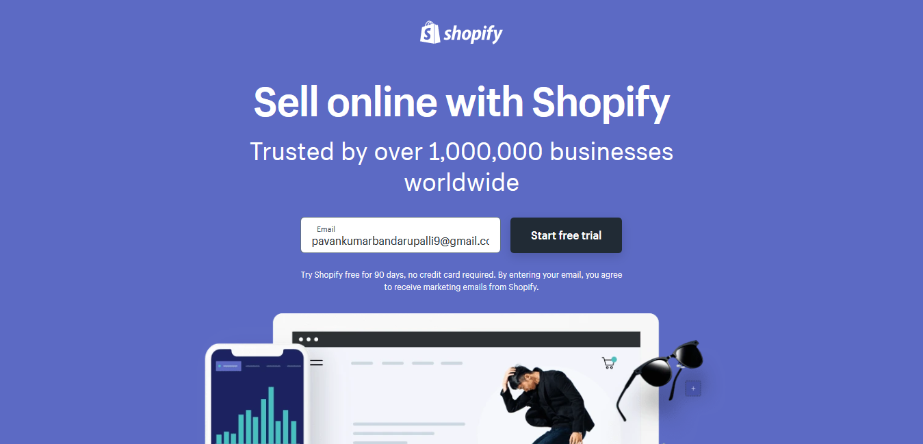

**Fig 3.1 Subscribe to Shopify**

Give your store a suitable name and click get started.

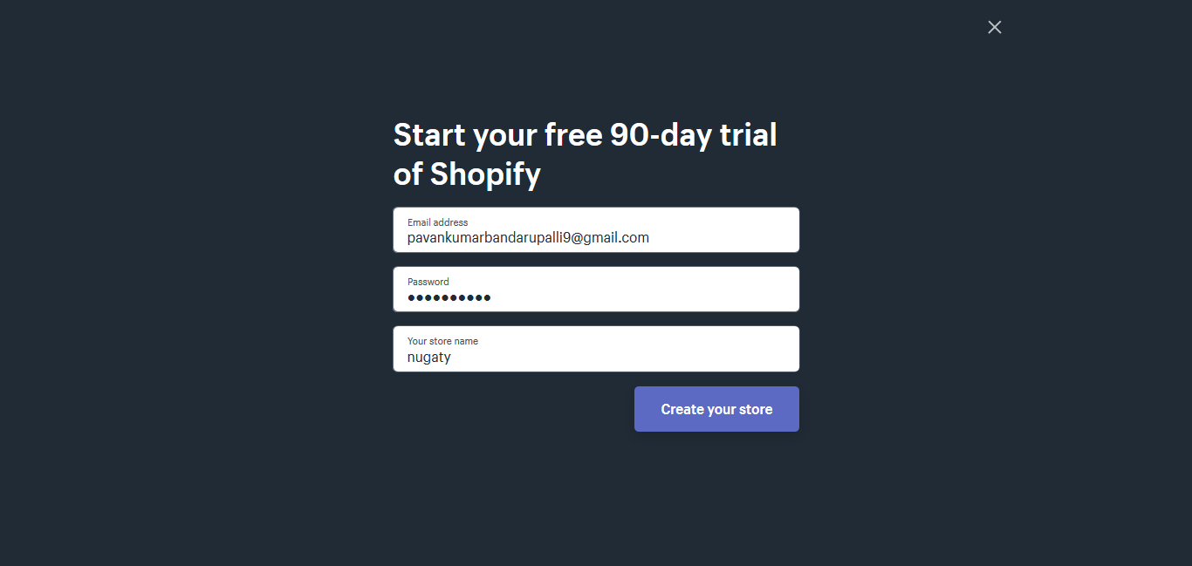

**Fig 3.2 Creating store in Shopify**

Add address to calculate tax and payment.

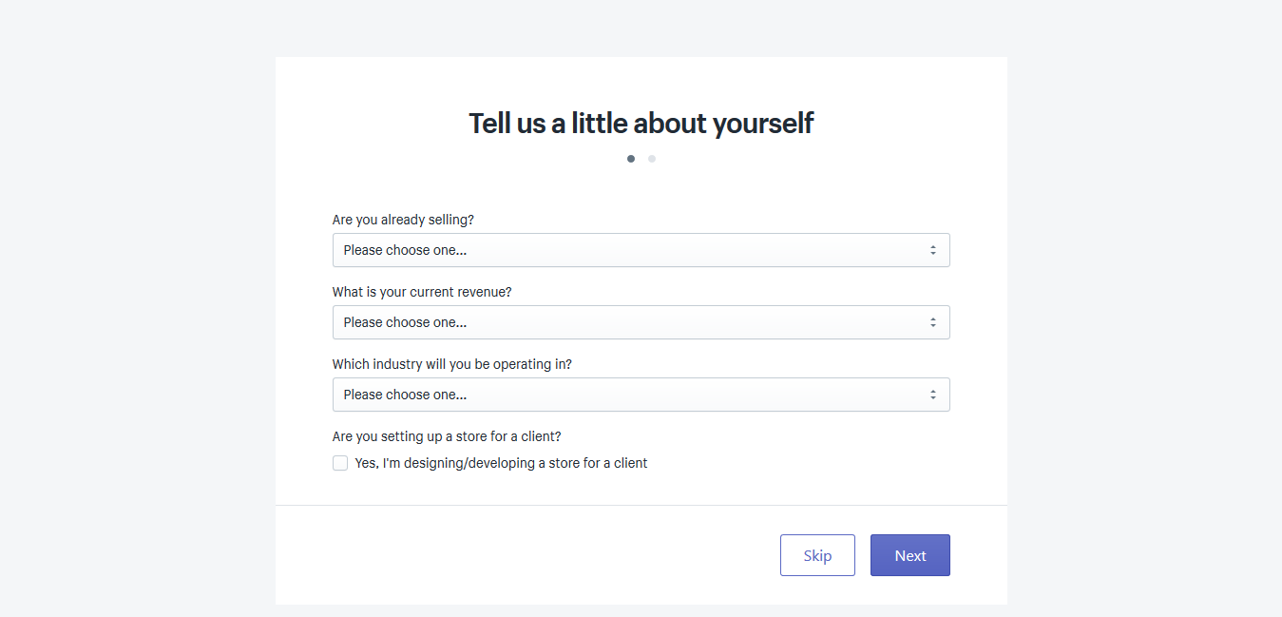

**Fig 3.3 Registering in Shopify**

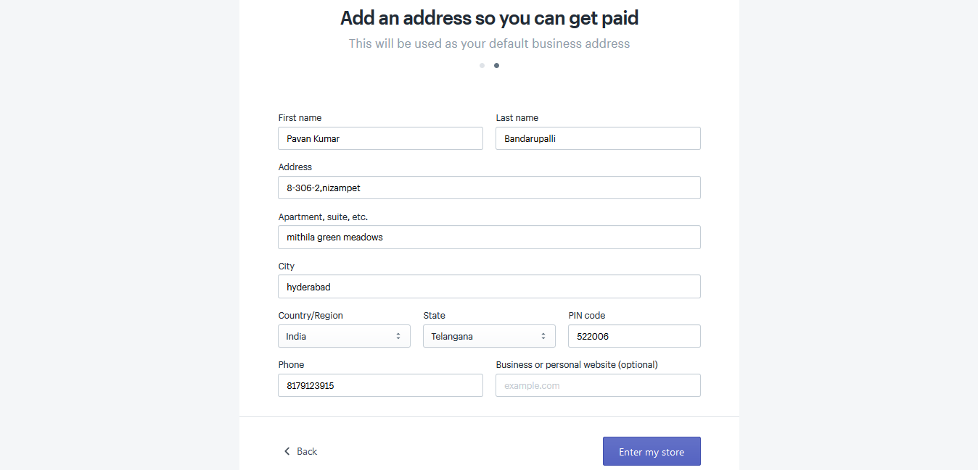

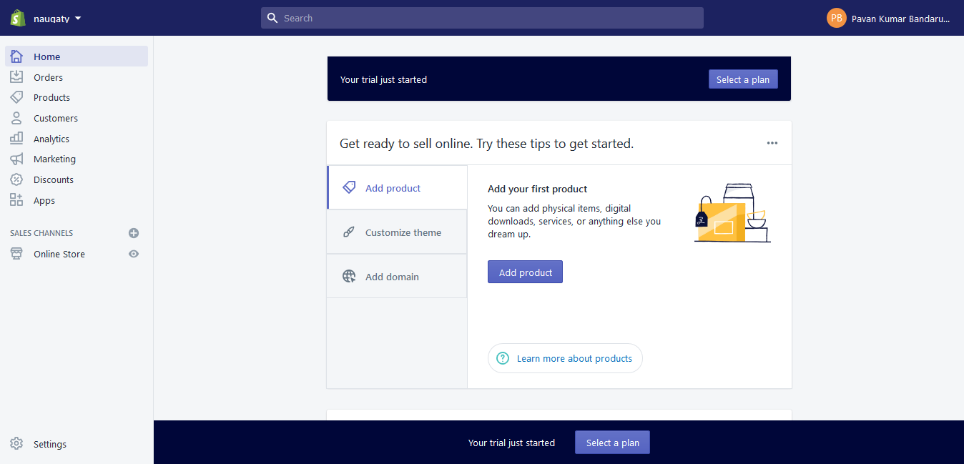

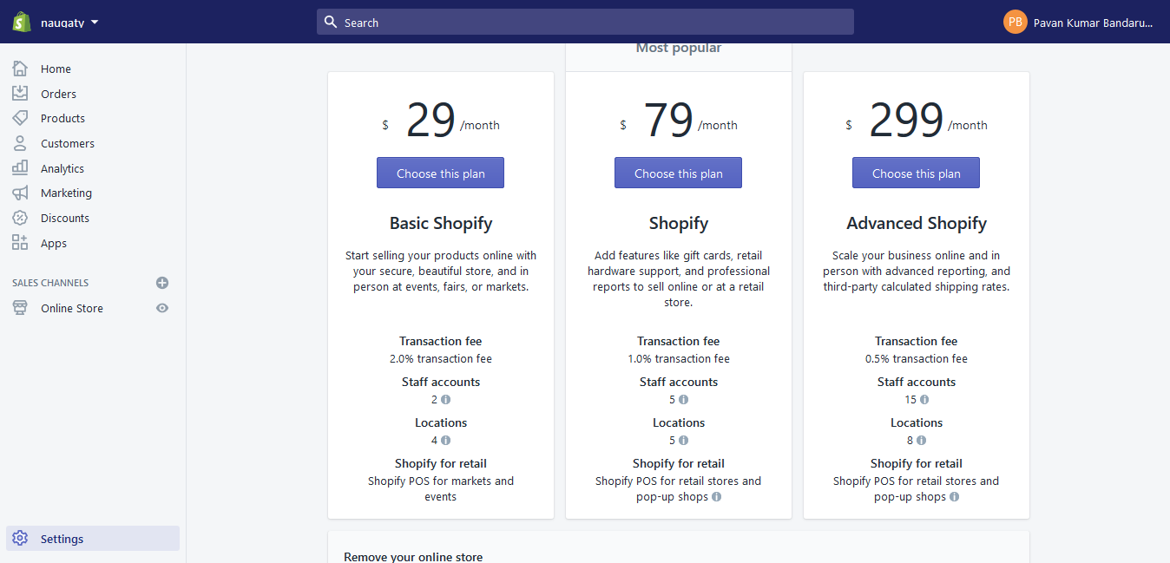

Start customizing the theme

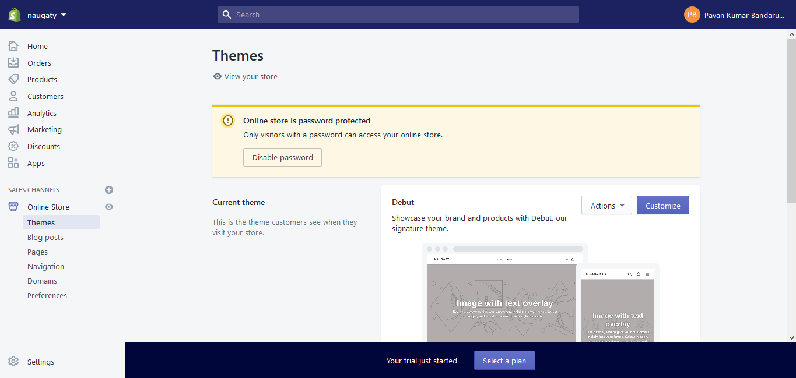

**Fig 3.4 Homepage of Shopify**

Also, if you don't like the default debut theme you can choose the theme from Shopify theme store. Shopify has more than 100 design templates, or ‘themes’ to customize your online store. Think of them as a starting point – you can tweak or amend the layouts, colours and images as you go through.

#### 3.2.2 Shopify Themes

At present there are 61 themes. In these 61 themes, 10 are free and the remaining is paid.

The following image shows the list of free themes

.

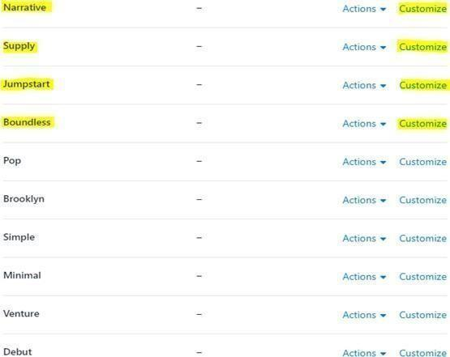

**Fig 3.5 Shopify themes**

Also, one can download themes that are based on Shopify liquid language and upload them to design their e-commerce store.

### 3.3 Action of a theme in Shopify

Shopify gives you plenty of control over the look and feel of your site. While selecting a theme for the store, a particular theme gives the user to select from a variety of 2 to 4 different styles of the theme.

Shopify offers a load of great-looking free designs. All you must do is just pick one. No design skills needed at all to launch a truly good-looking e-Commerce store on Shopify.

Actions drop-down gives the following features for a theme. In this section, the user can preview the theme, rename the particular theme, Duplicate the theme, Download the theme files, edit the code of the theme and edit the languages of the theme.

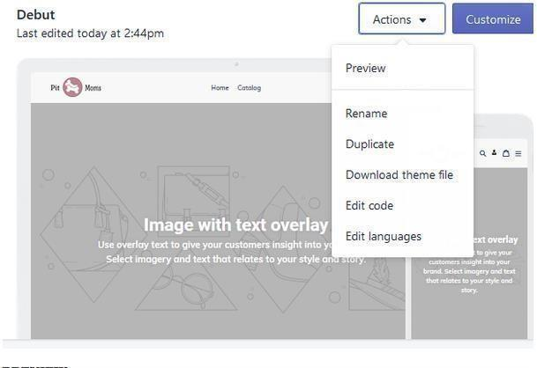

**Fig 3.6 Actions of theme**

### 3.4 General settings of theme in Shopify

In this section, one can completely change the feel and look of the store by using colors and different font styles. The checkout properties are also listed under this section.

#### 3.4.1 Colours

The settings for colour change in the theme are as shown below:

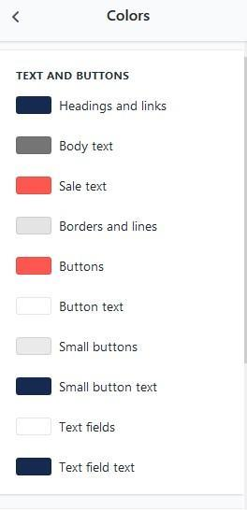

**Fig 3.7 Colour settings**

#### 3.4.2 Topography Options

In this, one changes font style and font sizes. Below image shows this.

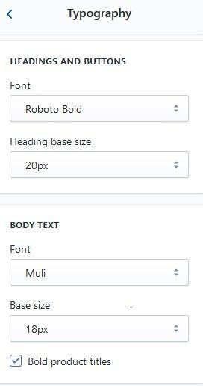

**Fig 3.8 Topography options**

#### 3.4.3 Social Media

Social media sharing options and the links for the social media website official pages’ like

Facebook, Twitter, Pinterest, Instagram, Tumblr, Snapchat, YouTube, Vimeo, etc. are given here.

#### 3.4.4 Favicon

Favicon is the logo or any other image of the store placed at the top left of the browser tab where the store is opened.

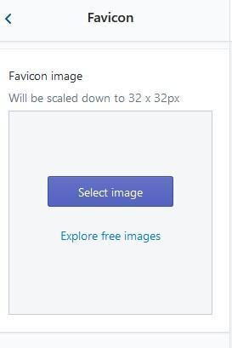

**Fig 3.9 Favourite icon settings**

#### 3.4.5 Checkout

Check out options like error messages and buttons in the checkout page can be made attractively by using this section. Also, the font style of the headings and body can be modified in this section.

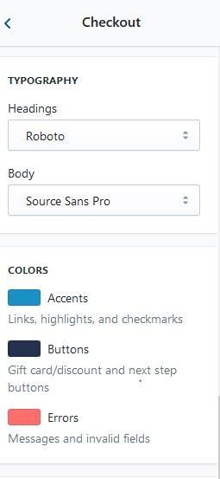

**Fig 3.10 Checkout settings**

### 3.5 Customizing theme in Shopify

Customizing tools vary according to the theme user has taken and here are the sample customizing tools for the theme ‘Debut’. Shopify not only features customizing of the theme but also general settings like colours, Typography, etc.

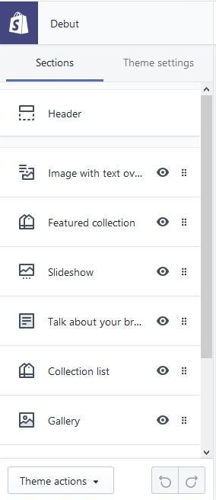

**Fig 3.11 Theme overview**

Also, from the Customization theme page, one can navigate to the editing code page using Theme actions which are located at the bottom left of customization tools.

### 3.6 Customizing sections

The below image shows the different sections of the customized website (In Debut Theme).

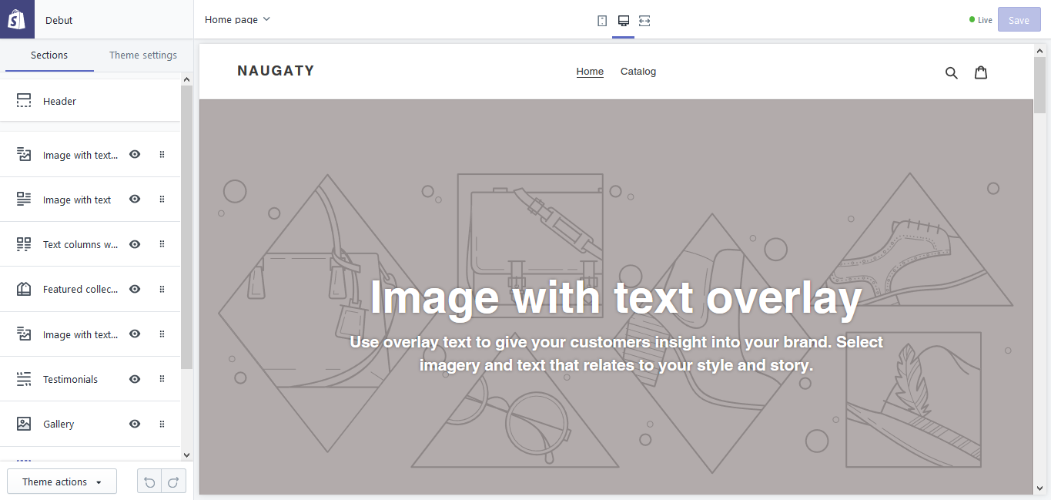

**Fig 3.12 Theme editor**

**CHAPTER - 4**

**MODELLING**

## 4. MODELLING

### 4.1 Modelling

Requirements gathering followed by careful analysis leads to a systematic Object Oriented Design (OOAD). Various activities have been identified and are represented using Unified Modelling Language (UML) diagrams. UML is used to specify, visualize, modify, construct and document the artifacts of an object-oriented software-intensive system under development.

### 4.2 UML Modelling diagrams

#### 4.2.1 Use Case Diagrams

##### 4.2.1.1 Definition

To model a system, the most important aspect is to capture the dynamic behaviour. Dynamic behaviour means the behaviour of the system when it is running/operating.

Only static behaviour is not enough to model a system rather dynamic behaviour is more important than static behaviour. In UML, there are five diagrams available to model the dynamic nature and use case diagram is one of them. Now as we must discuss that the use case diagram is dynamic in nature, there should be some internal or external factors for making the interaction.

These internal and external agents are known as actors. Use case diagrams consist of actors, use cases and their relationships. The diagram is used to model the system/subsystem of an application. A single use case diagram captures a particular functionality of a system.

Hence to model the entire system, a number of use case diagrams are used.

**4.2.1.2 Why Use Case Diagrams?**

Use case diagrams are used to gather the requirements of a system including internal and external influences. These requirements are mostly design requirements. Hence, when a system is analysed to gather its functionalities, use cases are prepared and actors are identified.

When the initial task is complete, use case diagrams are modelled to present the outside view.

In brief, the purposes of use case diagrams can be said to be as follows −

* Used to gather the requirements of a system.
* Used to get an outside view of a system.
* Identify the external and internal factors influencing the system.
* Show the interaction among the requirements are actors.

##### 4.2.1.3 Modelling of Use Case Diagrams

Use case diagrams are drawn to capture the functional requirements of a system. After identifying the above items, we must use the following guidelines to draw an efficient use case diagram

* The name of a use case is very important. The name should be chosen in such a way so that it can identify the functionalities performed.
* Give a suitable name for actors.
* Show relationships and dependencies clearly in the diagram.
* Do not try to include all types of relationships, as the main purpose of the diagram is to identify the requirements.
* Use notes whenever required to clarify some important points.

Following is a sample use case diagram representing the order management system. Hence, if we look into the diagram then we will find three use cases (Order, Special-order, and Normal Order) and one actor which is the customer.

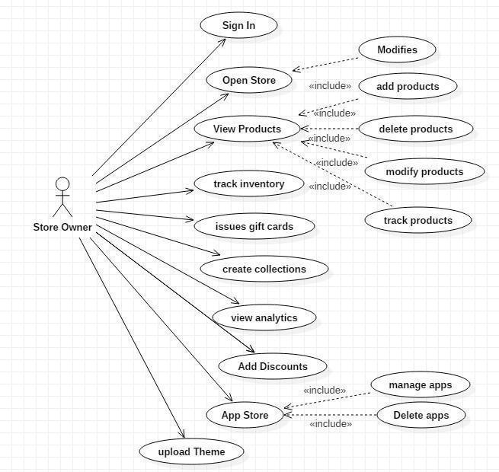

**Fig 4.1 Use Case Diagram for the system**

#### 4.2.2 Sequence Diagram

**4.2.2.1 Definition:**

UML sequence diagrams are used to show how objects interact in a given situation. An important characteristic of a sequence diagram is that time passes from top to bottom: the interaction starts near the top of the diagram and ends at the bottom (i.e. Lower equals later).

A popular use for them is to document the dynamics in an object-oriented system. For each

key, collaboration diagrams are created that show how objects interact in various representative scenarios for that collaboration.

Sequence diagram is the most common kind of interaction diagram, which focuses on the message interchange between a number of lifelines.

The following nodes and edges are typically drawn in a UML sequence diagram: lifeline, execution specification, message, combined fragment, interaction use, state invariant, continuation, destruction occurrence.

**4.2.2.2 Why Sequence Diagrams?**

The purpose of sequence diagrams is to visualize the interactive behaviour of the system. Visualizing the interaction is a difficult task. Hence, the solution is to use different types of models to capture the different aspects of the interaction.

Sequence diagrams are used to capture the dynamic nature but from a different angle. The purpose of sequence diagram is −

* To capture the dynamic behaviour of a system.
* To describe the message flow in the system.
* To describe the structural organization of the objects. •To describe the interaction among objects.

##### 4.2.2.3 Modelling of Sequence Diagram

The sequence diagram captures the time sequence of the message flow from one object to another. Following things are to be identified clearly before drawing the interaction diagram

* Objects taking part in the interaction.
* Message flows among the objects.
* The sequence in which the messages are flowing.
* Object organization.

The following diagram shows the message sequence for Special Order object and the same can be used in case of Normal Order object. It is important to understand the time sequence of message flows. The message flow is nothing, but a method calls of an object.

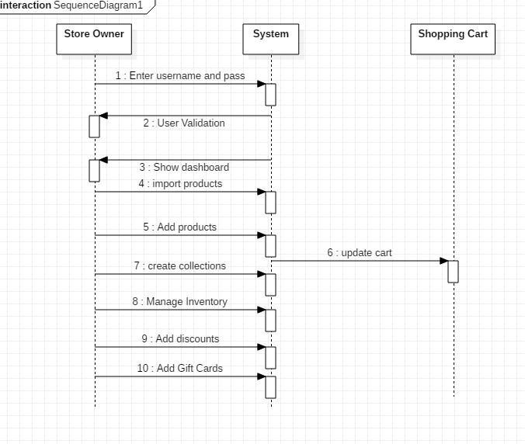

**Fig 4.2 Sequence Diagram for Admin**

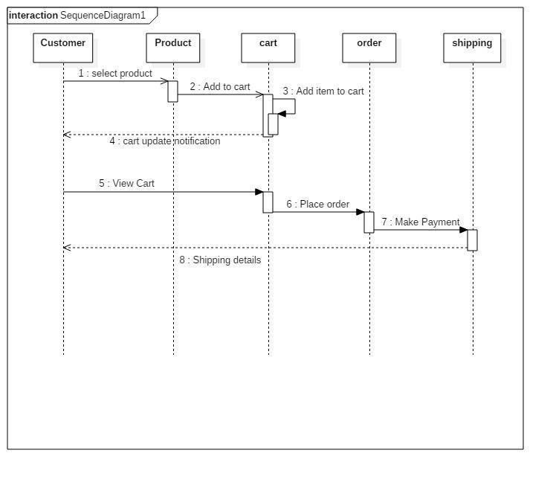

**Fig 4.3 Sequence Diagram for entire system**

#### 4.2.3 Activity Diagram

##### 4.2.3.1 Definition

Activity diagram is another important diagram in UML to describe dynamic aspects of the system. Activity diagram is basically a flow chart to represent the flow form one activity to another activity. The activity can be described as an operation of the system. So the control flow is drawn from one operation to another. This flow can be sequential, branched or concurrent. Activity diagrams deals with all type of flow control by using different elements like fork, join etc. Activity is a particular operation of the system.

**4.2.3.2 Why Activity Diagram?**

Activity is a particular operation of the system. Activity diagrams are not only used for visualizing the dynamic nature of a system, but they are also used to construct the executable system by using forward and reverse engineering techniques. The only missing thing in the activity diagram is the message part.

It does not show any message flow from one activity to another. Activity diagram is sometimes considered as the flowchart. Although the diagrams look like a flowchart, they are not.

It shows different flows such as parallel, branched, concurrent, and single.

The purpose of an activity diagram can be described as –

* Draw the activity flow of a system.
* Describe the sequence from one activity to another.
* Describe the parallel, branched and concurrent flow of the system.

##### 4.2.3.3 Modelling of Activity Diagrams

Before drawing an activity diagram, we must have a clear understanding about the elements used in the activity diagram. The main element of an activity diagram is the activity itself. An activity is a function performed by the system. After identifying the activities, we need to understand how they are associated with constraints and conditions.

Before drawing an activity diagram, we should identify the following elements –

* Activities
* Association
* Conditions
* Constraints

Once the above-mentioned parameters are identified, we need to make a mental layout of the entire flow. This mental layout is then transformed into an activity diagram.

Following is an example of an activity diagram for order management system. In the diagram, four activities are identified which are associated with conditions. One important point should be clearly understood that an activity diagram cannot be exactly matched with the code. The activity diagram is made to understand the flow of activities and is mainly used by the business users

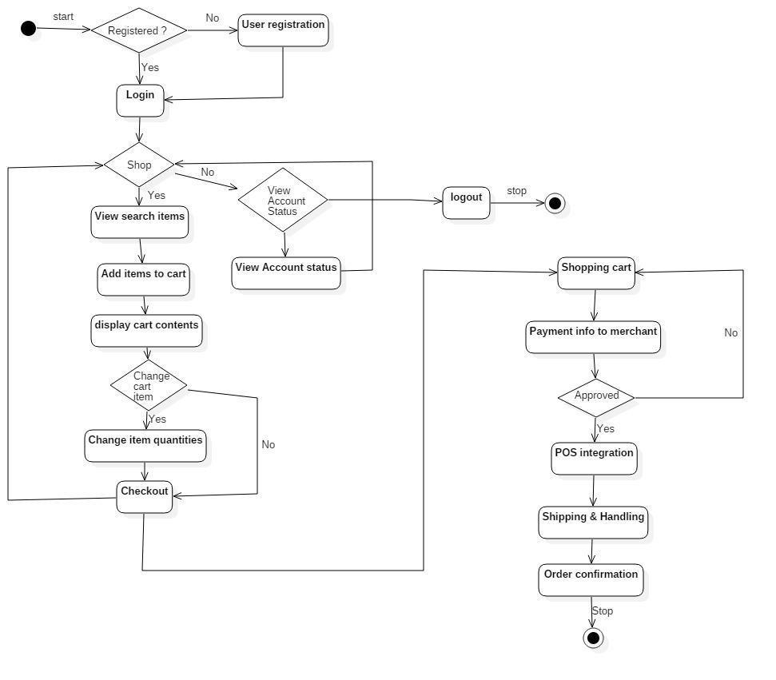

**Fig 4.4 Activity Diagram for E-commerce Order Process**

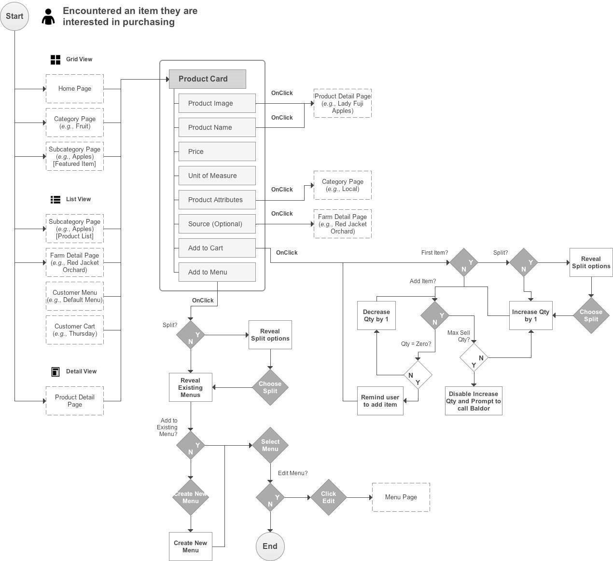

**Fig 4.5 Activity diagram for entire system**

#### 4.2.4 Class Diagram

##### 4.2.4.1 Definition

In software engineering, a class diagram in the Unified Modelling Language (UML) is a type of static structure diagram that describes the structure of a system by showing the system’s classes, their attributes, operations (or methods), and the relationships among the classes.

The class diagram is the main building block of object-oriented modelling. It is used both for general conceptual modelling of the modelling of the application, and for detailed modelling translating the models into programming code. Class diagrams can also be used for data modelling. The classes in a class diagram represent both the main objects, interactions in the application and the classes to be programmed.

**4.2.4.2 Why Class Diagrams?**

The purpose of class diagrams is to model the static view of an application. Class diagrams are the only diagrams which can be directly mapped with object-oriented languages and thus widely used at the time of construction.

UML diagrams like activity diagrams, sequence diagrams can only give the sequence flow of the application, however class diagrams are a bit different. It is the most popular UML diagram in the coder community.

The purpose of the class diagram can be summarized as −

* Analysis and design of the static view of an application.
* Describe responsibilities of a system.
* Base for component and deployment diagrams.
* Forward and reverse engineering.

##### 4.2.4.3 Modelling of Class Diagrams

Class diagram is basically a graphical representation of the static view of the system and represents different aspects of the application. A collection of class diagrams represents the whole system.

The following points should be remembered while drawing a class diagram −

* The name of the class diagram should be meaningful to describe the aspect of the system.
* Each element and their relationships should be identified in advance.
* Responsibility (attributes and methods) of each class should be clearly identified.
* For each class, minimum number of properties should be specified, as unnecessary properties will make the diagram complicated.
* Use notes whenever required to describe some aspect of the diagram. At the end of the drawing it should be understandable to the developer/coder.
* Finally, before making the final version, the diagram should be drawn on plain paper and reworked as many times as possible to make it correct.

The following diagram is an example of an Order System of an application. It describes a particular aspect of the entire application.

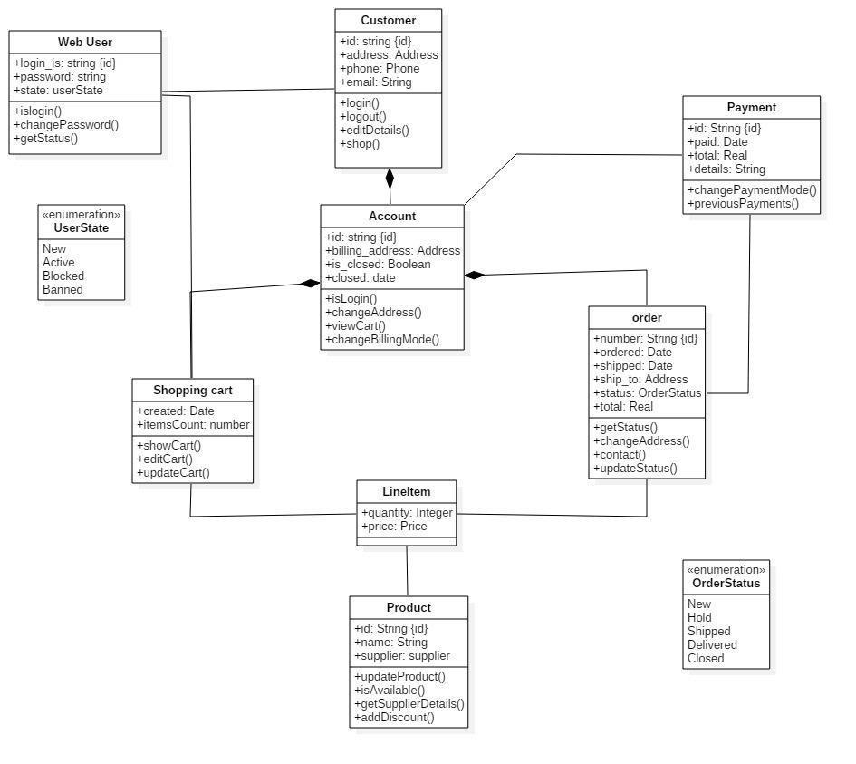

**Fig 4.6 Class Diagram for online shopping**

### 4.3 ER DIAGRAMS

An ER model is an abstract way to describe a database. Describing a database usually starts with a relational database, which stores data in tables. Some of the data in these tables point to data in other tables - for instance, your entry in the database could point to several entries for each of the phone numbers that are yours. The ER model would say that you are an entity, and each phone number is an entity, and the relationship between you and the phone numbers is 'has a phone number'. Diagrams created to design these entities and relationships are called entity– relationship diagrams or ER diagrams.

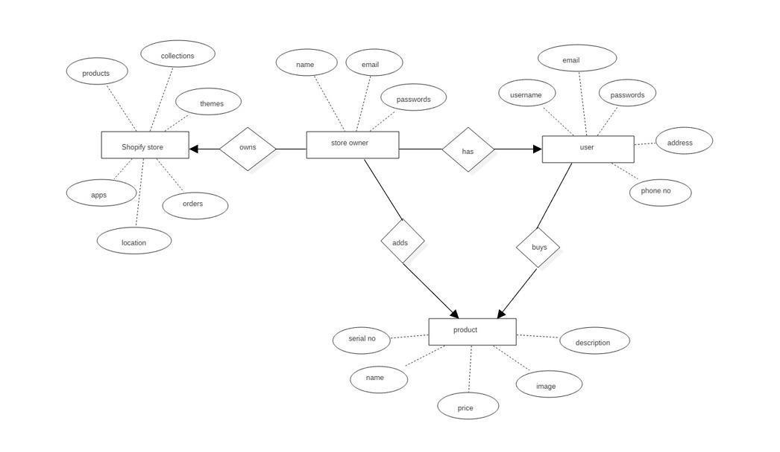

**Fig 4.7 ER Diagram**

**CHAPTER – 5**

**IMPLEMENTATION**

## 5.IMPLEMENTATION

## 5.1 Introduction to Implementation

During the implementation process, engineers apply the design properties and/or requirements allocated to a system element to design and produce a detailed description. They then fabricate, code, or build each individual element using specified materials, processes, physical or logical arrangements, standards, technologies, and/or information flows outlined in detailed descriptions (drawings or other design documentation). A system element will be verified against the detailed description of properties and validated against its requirements.

### 5.2 Introduction to liquid

Liquid is a template language that creates dynamic web pages using tags, objects and filters.

#### 5.2.1 Tags

Tags in liquid are useful for conditional logic. There are for tags, comment tags and many more.

The syntax for giving comments in liquid is

* {%comment%} Content to be in comments {%endcomment%}.
* The Syntax for tag is {%for var in Object%} Code {%endfor%}.

The Syntax for if tag is

* {%if Condition1%} Code {%elsif Condition 2%} Code

{%else%} Code {%endif%}.

#### 5.2.2 Objects

These are used to display dynamic content of page in Shopify. To output an object attribute use {{object. Attribute_name}}.

There are two kinds of objects namely global objects that can be accessed anywhere and local objects that are specific to particular code.

⮚Cart, Collections and Customers are some of the global objects.

⮚Content_for _header and content_for_index are other local objects.

#### 5.2.3 Filters

Filters in Liquid are used to modify the output of strings, objects etc.., There are many kinds

of filters like Math filters, String filters etc.,

⮚For example, {{product. Title | uppercase}} displays title of product in upper case format.

### 5.3 Code organization on Shopify platform

A theme is a collection of files that has code regarding how to display a web page. Most of the files have an ‘extension.liquid’. The files ‘having.liquid’ are known as liquid templates.

The following are the categories of files present in a theme:

* Layout files control the layout of the theme.
* Template files control layout of specific pages like Blog pages or product pages.
* Snippets are the files that contains specific code block which can be useful many times by other files.
* Assets are nothing but images, style sheets, scripts and fonts.
* Configuration files has settings and configuration data of the theme.
* Language files have content regarding languages pieces of text needed for the theme.
* Section files control layout of various sections of the theme.

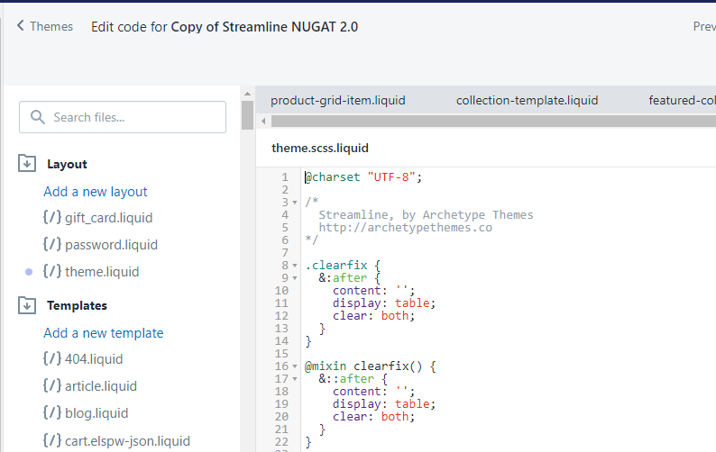

**Fig 5.1 Code organization**

### 5.4 Getting started with theme customizations

To work with a theme, one should create a Shopify partner account. To create a free partner account visit [https://partners.shopify.com.](https://partners.shopify.com/)

The dashboard of Shopify partner account is as follows:

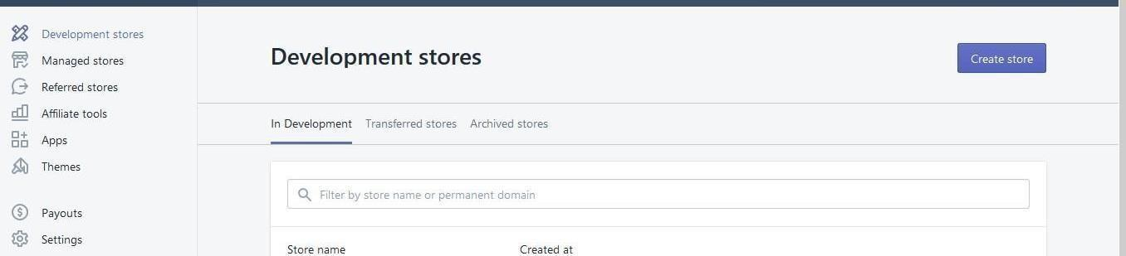

**Fig 5.2 Shopify partner dashboard**

### 5.5 Sample code

**5.5.1 Liquid code**

### <div class="root">

### {% if settings.animate_page_transitions %}

### <script>window.setTimeout(function() { document.body.className += " loaded"; },

### 25);</script>

### {% endif %}

### {%- assign loader_size = settings.desktop_loader_width | append: 'x' -%}

### {%- assign loader_size_mobile = settings.mobile_loader_width | append: 'x' -%}

### <div class="splash-screen">

### {% if settings.logo_loader_image != blank }

<div class="splash-screen__loader">

<img

class="loader-logo__img"

src="{{ settings.logo_loader_image | img_url: loader_size }}"

srcset="{{ settings.logo_loader_image | img_url: loader_size }} 1x,

{{ settings.logo_loader_image | img_url: loader_size, scale: 2 }} 2x” aria-hidden="true">

</div>

{% else %}

<span class="loader-text">{{ 'general.accessibility.loading' | t }}</span>

{% endif %}

</div>

<a class="in-page-link visually-hidden skip-link" href="#MainContent">{{ 'general.accessibility.skip_to_content' | t }}</a>

<div id="PageContainer" class="page-container">

<div class="transition-body">

{% section 'header' %}

<main class="main-content" id="MainContent">

{{ content_for_layout }}

</main>

{% section 'instagram' %}

{% section 'footer' %}

</div>

</div>

{% section 'newsletter-popup' %}

{% if settings.enable_currencies %}

{% include 'currency-modal' %}

{% endif %}

{% include 'video-modal' %}

{% if settings.animate_page_transition_style == 'page-logo' %}

<div class="loader-logo">

{% if settings.logo_loader_image != blank %}

<div class="splash-screen__loader">

<img

class="loader-logo__img"

src="{{ settings.logo_loader_image | img_url: loader_size }}"

srcset="{{ settings.logo_loader_image | img_url: loader_size }} 1x, {{ settings.logo_loader_image | img_url: loader_size, scale: 2 }} 2x"

aria-hidden="true">

</div>

{% else %}

<span class="loader-text">{{ 'general.accessibility.loading' | t }}</span>

{% endif %}

</div>

{% endif %}

</div>

#### 5.4.2 Schema

### .skrim-grid {

### display: -ms-flexbox;

### display: flex;

### -ms-flex-pack: center;

### justify-content: center;

### -ms-flex-line-pack: center;

### align-content: center;

### -ms-flex-wrap: wrap;

### flex-wrap: wrap;

### margin: 0 -20px;

### @include media-query($medium-up) {

### margin-bottom: -$grid-gutter;

### }

### }

### . skrim__item {

### position: relative;

### overflow: hidden;

### width: 40%;

### width: calc(30% - 10px);

### margin: 0 (20px / 2) 20px;

### @include media-query($medium-up) {

### margin: 0 ($grid-gutter / 2) $grid-gutter;

### width: 20%;

### width: calc(25% - #{$grid-gutter});

### }

### &:after {

### content: '';

### display: block;

### padding-bottom: 100%;

### }

### }

### .skrim__link {

### display: block;

### position: absolute;

### overflow: hidden;

### height: 100%;

### width: 100%;

### border-radius: $button-radius * 0.71;

### will-change: transform;

### @include media-query($medium-up) {

### border-radius: $button-radius;

### }

### @if ($animate_images) {

### &:hover,

### &:focus {

### .skrim__overlay {

### transform: scale(1.03);

### transition-duration: 0.8s;

### }

### .skrim__overlay:before {

### opacity: 0.3;

### transition-duration: 0.5s;

### }

### }

### }

### }

### .skrim__overlay {

### position: relative;

### display: block;

### overflow: hidden;

### height: 100%;

### width: 100%;

### background-size: cover;

### background-repeat: no-repeat;

### background-position: center;

### transition: transform 0.5s ease;

### &:after {

### @include overlay();

### @include heroScrim();

### transition: all 0.5s ease;

### }

### &:before {

### @include overlay();

### background: #000;

### opacity: 0.15;

### transition: opacity 0.2s ease;

### }

### }

### .skrim__title {

### @include headerFontStack;

### position: absolute;

### top: 0;

### bottom: 0;

### left: 0;

### right: 0;

### margin: 0 ($gutter/1.6/2) 0;

### color: $colorHeroText;

### transition: bottom 0.5s ease;

### display: -ms-flexbox;

### display: flex;

### text-align: center;

### -ms-flex-align: center;

### align-items: center;

### -ms-flex-pack: center;

### justify-content: center;

### @include media-query($medium-up) {

### margin: 0 ($gutter/1.6);

### }

### &:before {

### @include heroRadial;

### background: radial-gradient(rgba(0,0,0,$colorImageOverlayTextShadow) 0%, rgba(0,0,0,0) 40%);

### margin: 35% -10%;

### }

### }

### .skrim__title--right {

### left: auto;

### right: 0;

### }

### .skrim__underline-me {

### position: relative;

### display: inline-block;

### }

### @if ($animate_underlines) {

### .skrim__underline-me:after {

### content: '';

### position: absolute;

### bottom: -4px;

### left: 0;

### width: 0%;

### border-bottom: $borderWidth solid $colorHeroText;

### transition: $animate_underlines_duration;

### }

### .skrim__link:hover {

### .skrim__underline-me:after {

### width: 100%;

### }

### .skrim__title {

### bottom: 10px;

### }

### }

### }

### Screenshots

#### 5.6 Front-end-view

#### 5.6.1 Home Page

A home page is a web page that serves as the starting point of a website. It is the default web page that loads when you visit a web address that only contains a domain name.

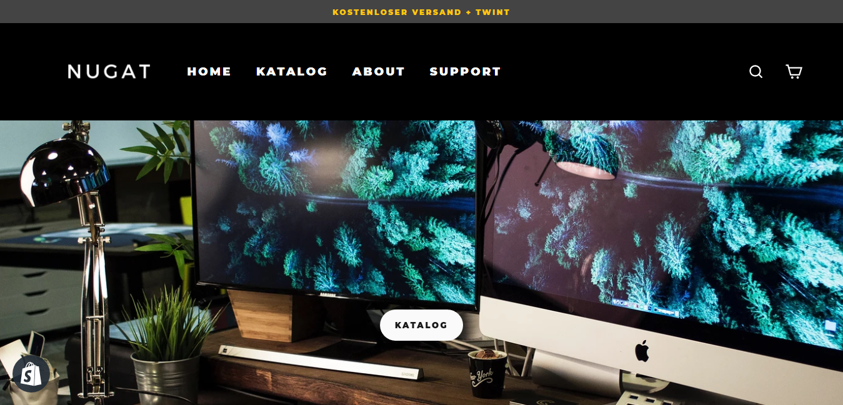

**Fig 5.3 Home Page**

**5.6.2 Strip Banner**

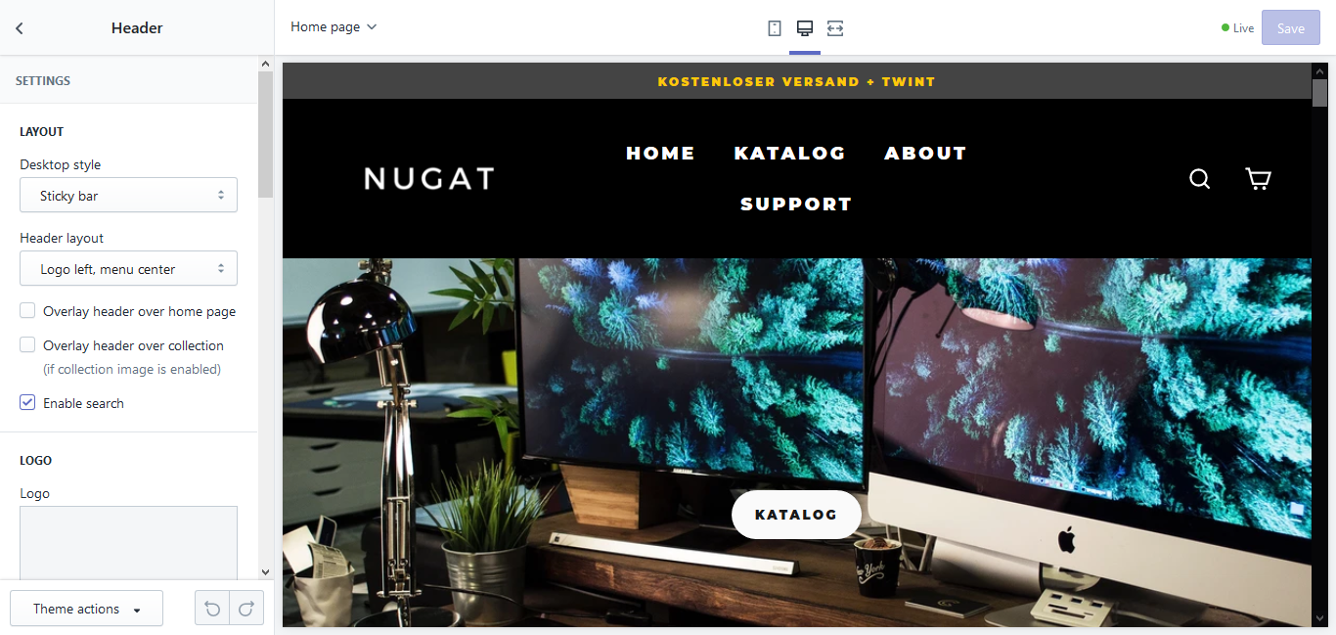

**Fig 5.4 Strip Banner**

**5.6.3 Featured Collection**

Featured collections would be a list curated by the owner (of the website) - likely to display on the homepage - to drive traffic to owners’ current priorities.

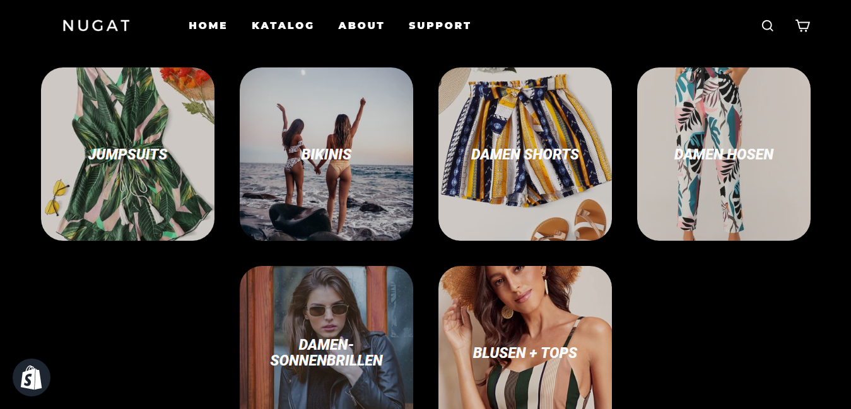

**Fig 5.5 Featured Collection**

**5.6.4 Slideshow**

A Sideshow is a presentation of a series of products in the store, which includes top and best collections.

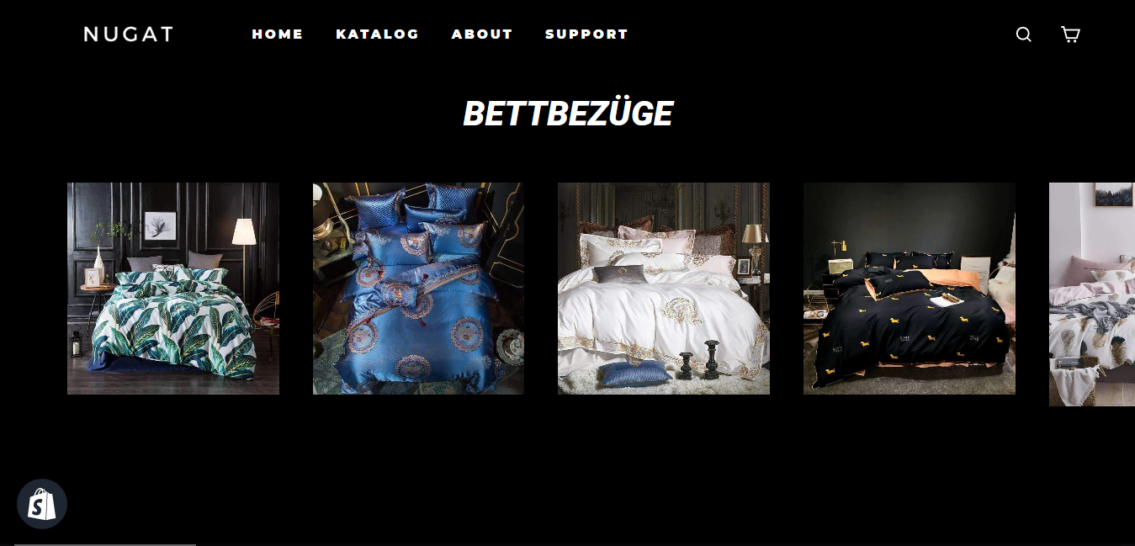

**Fig 5.6 Slide Show**

#### 5.6.5 Newsletter

Newsletters are often used by the owner of the website to add content, article, communicate an event on the store, the customers who visit the store can also communicate with the store owner. advertise a product.

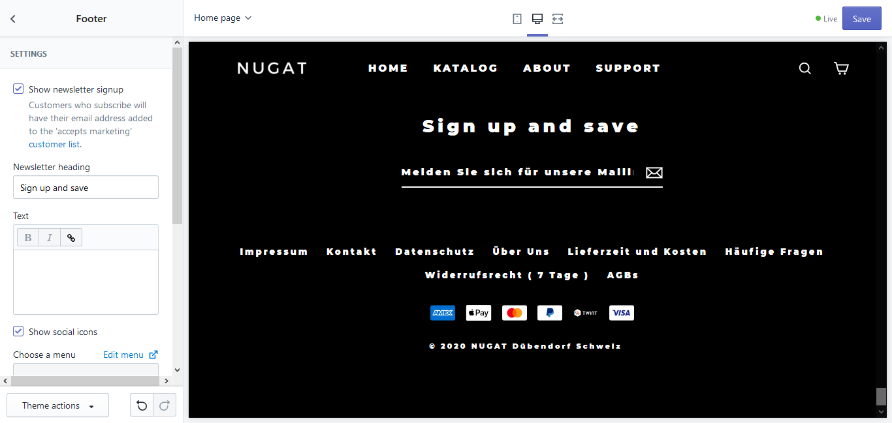

**Fig 5.7 Newsletter**

#### 5.6.6 Footer

This is the space where you want to inform your users about your product or service; it is also the place where shoppable products and top brands are displayed on.

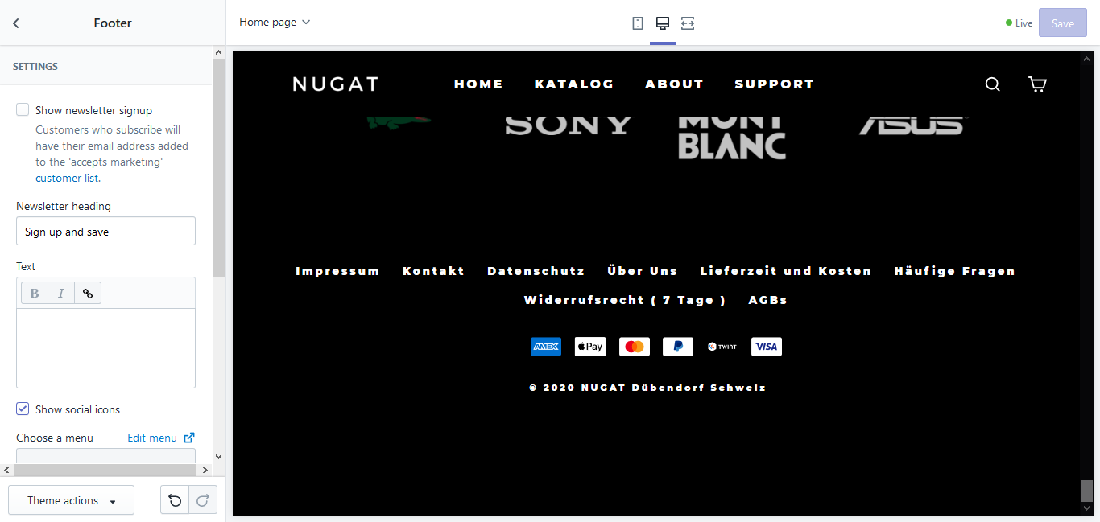

**Fig 5.8 Footer**

**5.6.8 Catalog**

It is the complete list of items in the store, typically one in alphabetical or other systematic order.

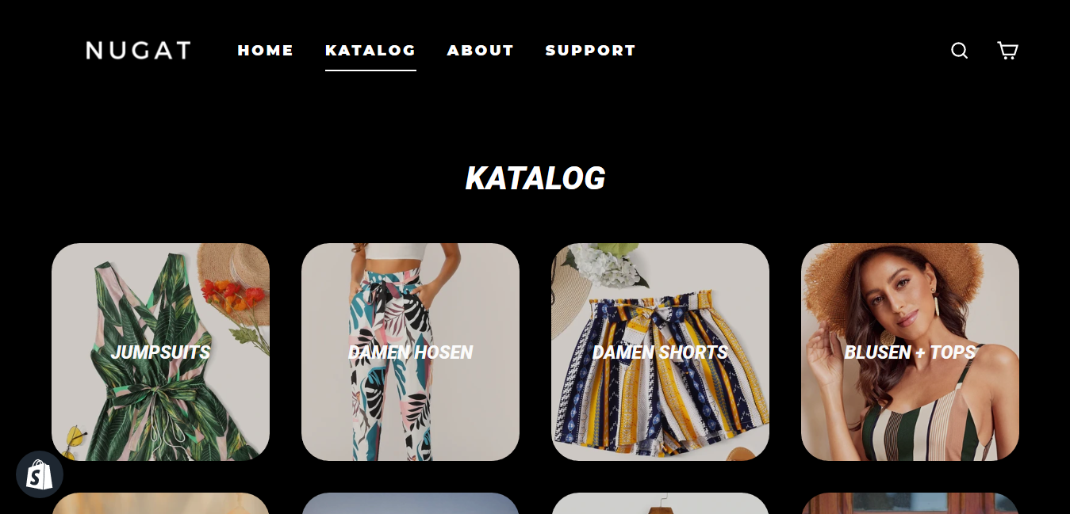

**Fig 5.9 Catalog**

**5.6.9 (a) Adding the product to cart**

It is the page where customers can pile up what they want to buy from the website and then simply checkout by paying online.

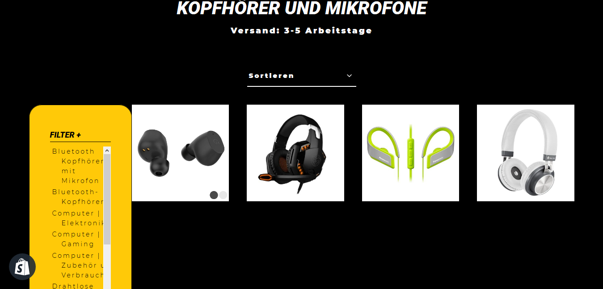

**Fig 5.10 Selecting the product to buy**

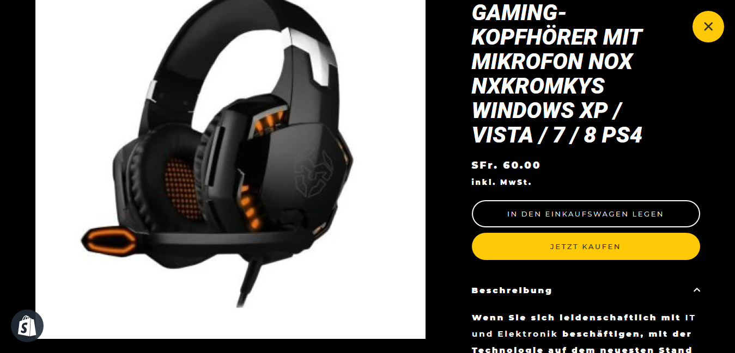

**Fig 5.11 Adding Product to Cart**

**5.6.9 (b) Checkout page**

A Checkout page refers to any website pages shown to a customer during the step-by-step checkout process

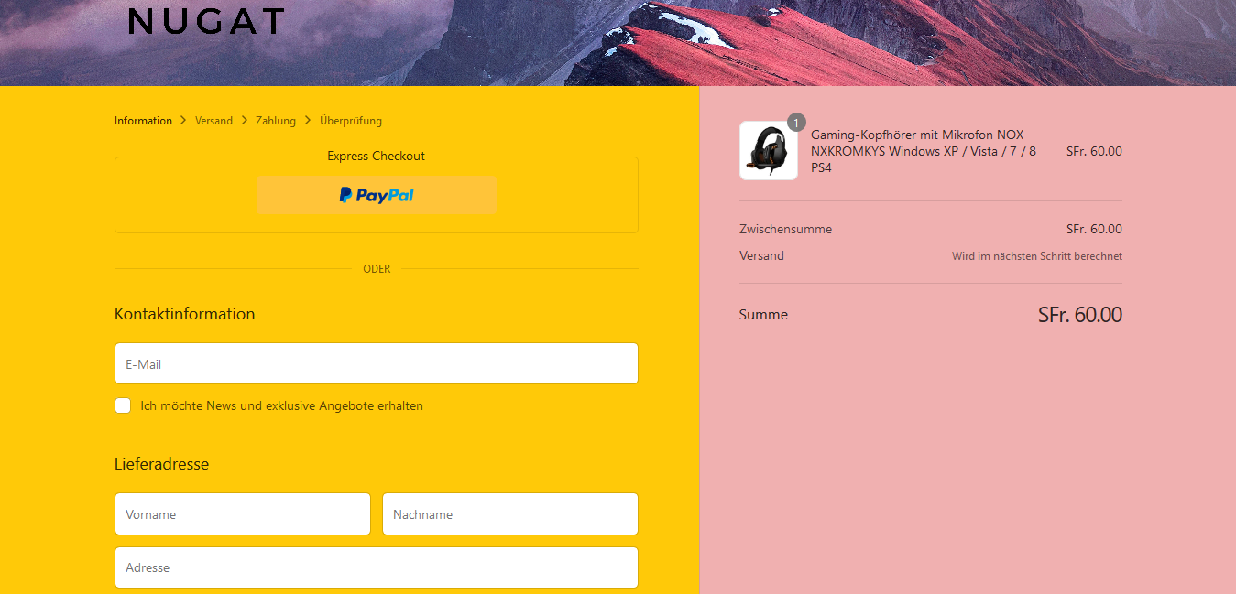

**Fig 5.12 Checkout page**

**5.6.10 About**

It is an article which resembles the store, it also consists of information about the owner(store).

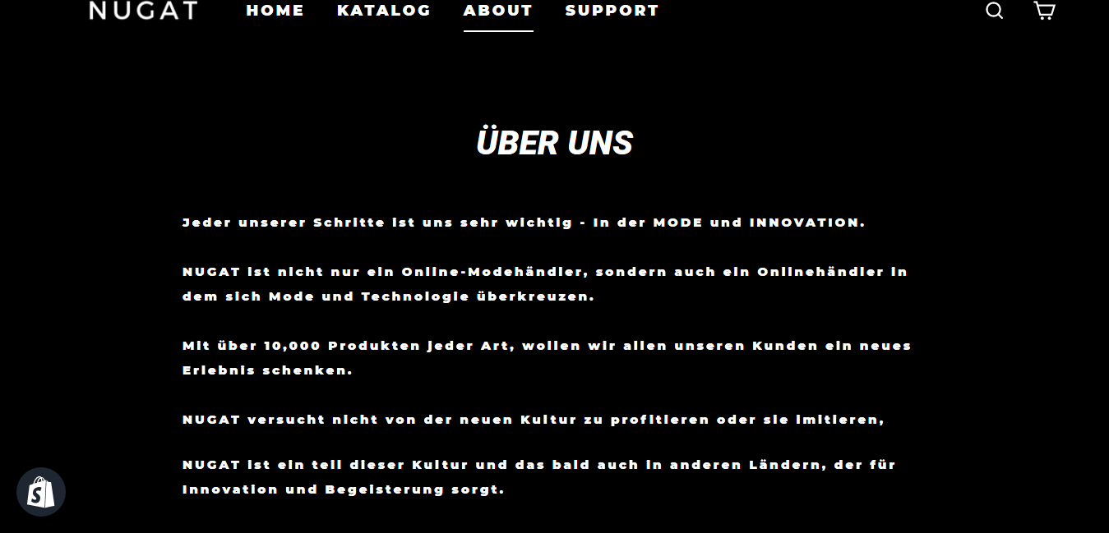

**Fig 5.13 About page**

**5.6.11 Support**

It is nothing but providing assistance to customers about the store and products.

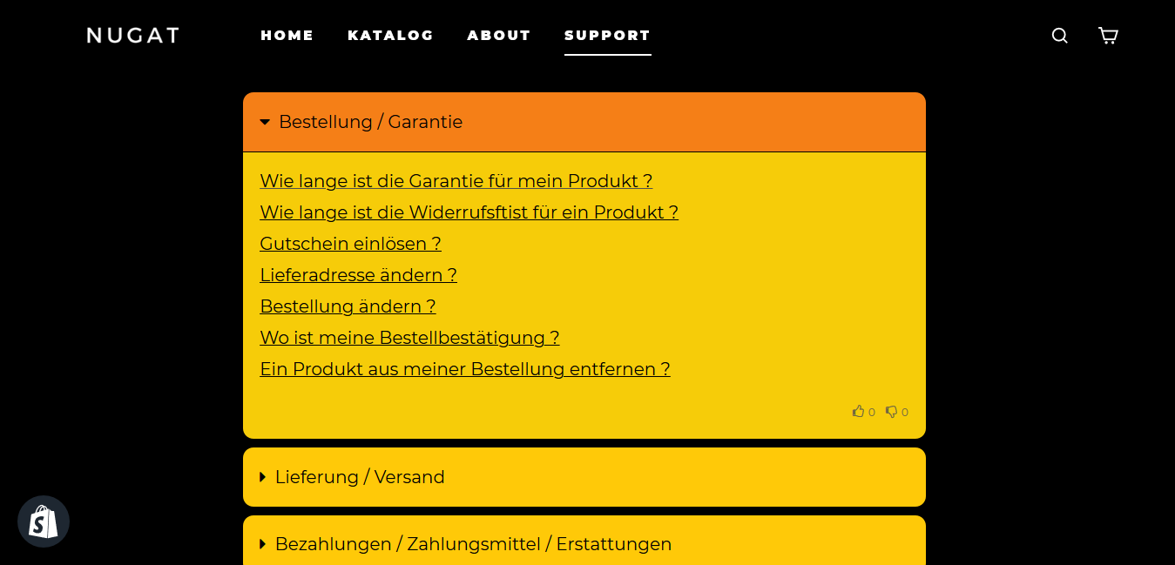

**Fig 5.14 Support page**

**5.7 Back-end View**

**5.7.1 Home Page**

This section defines what is within the store. You find pages in the Shopify admin

or search our most popular help documentation and blog posts.

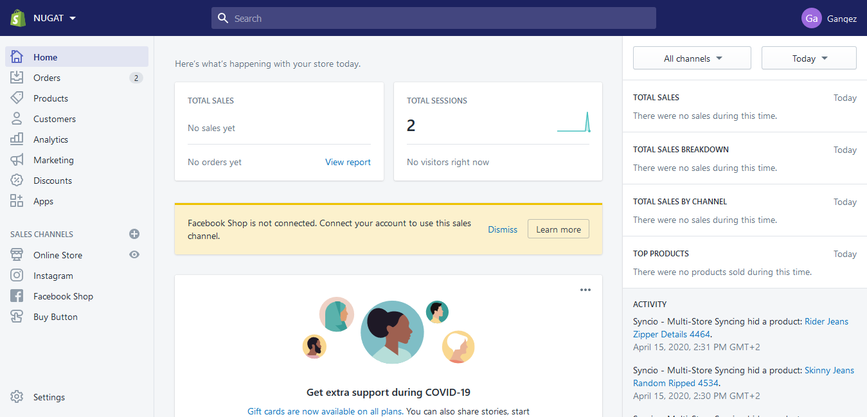

**Fig 5.15 Home Page**

**5.7.2 Orders Page**

Create orders manually in Shopify admin to record orders that you've made outside of Shopify or to send your customers email invoices.

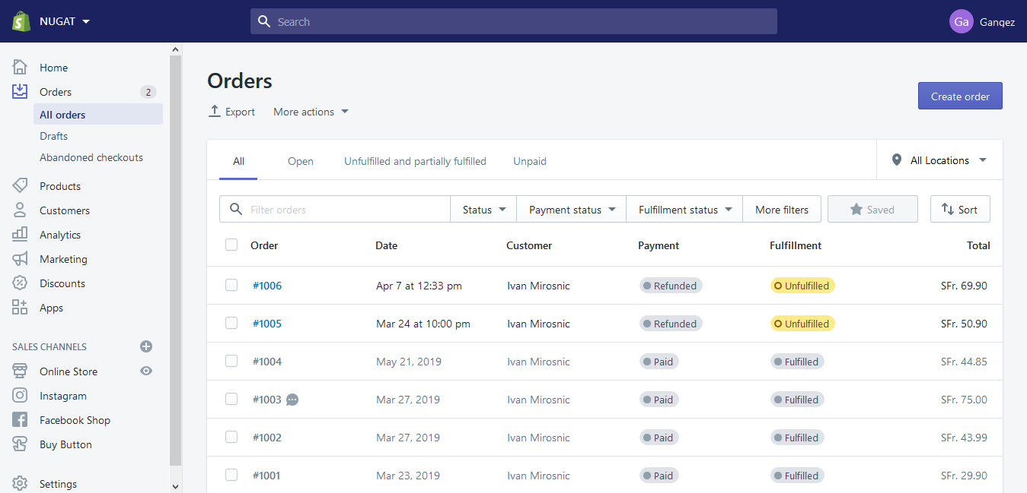

**Fig 5.16 Orders Page**

**5.7.3 Products Page**

Products are the goods, digital downloads, services, and gift cards that you sell. We can add a product in Shopify by entering product details and uploading product images.

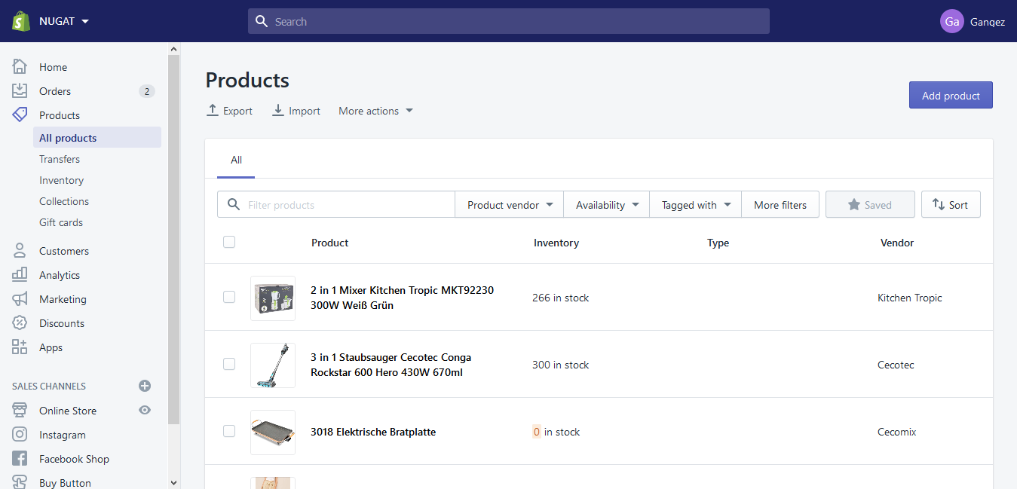

**Fig 5.17 Products Page**

**5.7.4 Inventory Page**

Inventory is the quantity of a particular product that is available for sale. Inventory tracking can help you avoid selling products that have run out of stock, or let you know when you need to order.

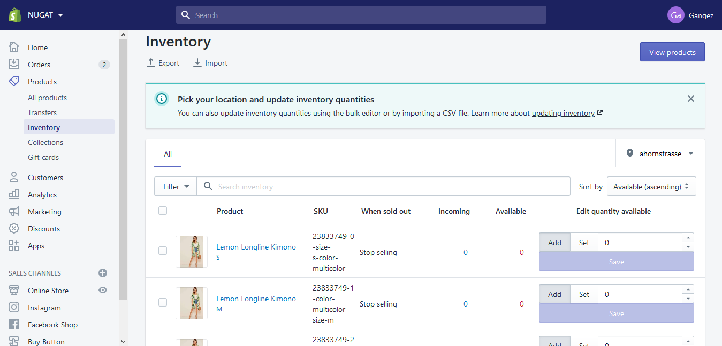

**Fig 5.18 Inventory Page**

**5.7.5 Collections Page**

Group the products into collections to make it easier for customers to find them by category. You can add up to 60 selection conditions.

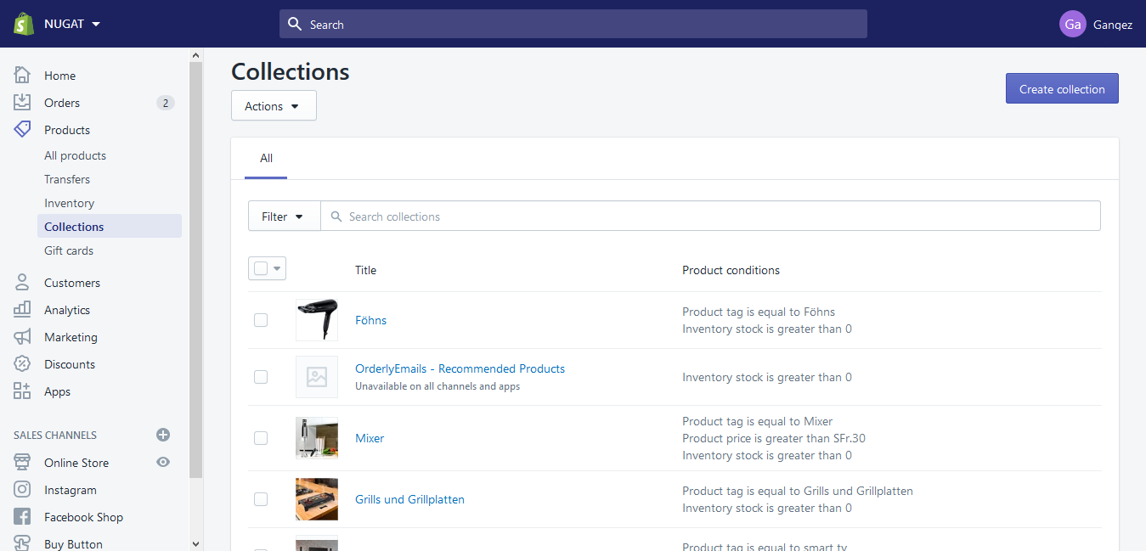

**Fig 5.19 Collections Page**

**5.7.6 Customers Page**

Interacting with your customers is an important part of running your business. If customers create an account with your store, then they can add their address information to their account so that it auto fills during checkout.

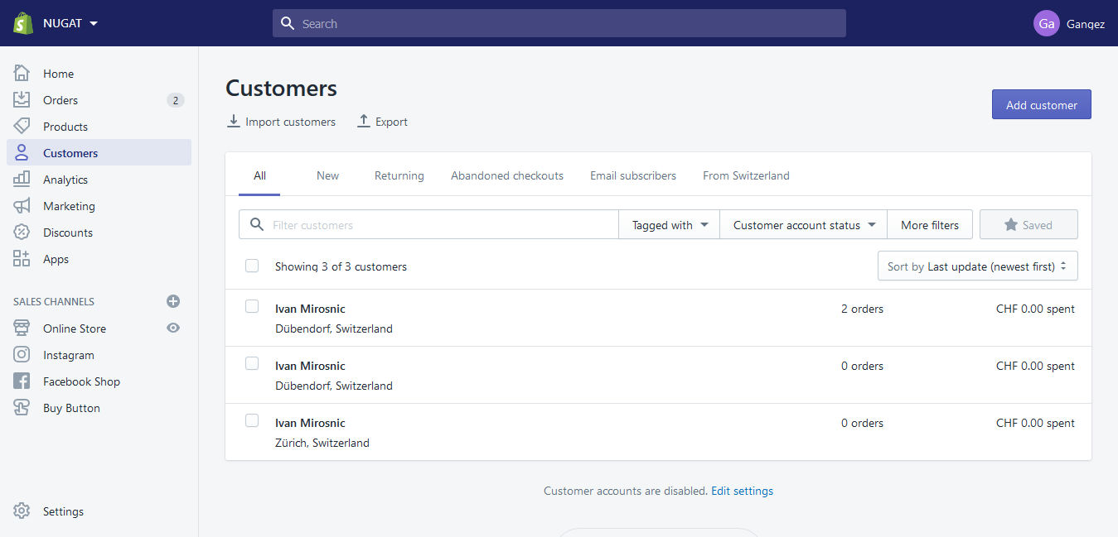

**Fig 5.20 Customers Page**

**5.7.7 Analytics**

1. **Dashboard**

Shopify's analytics and reports to learn about your sales and customers in detail. We can also set up third-party analytics services, such as Google Analytics, to gain further insights and improve your business.

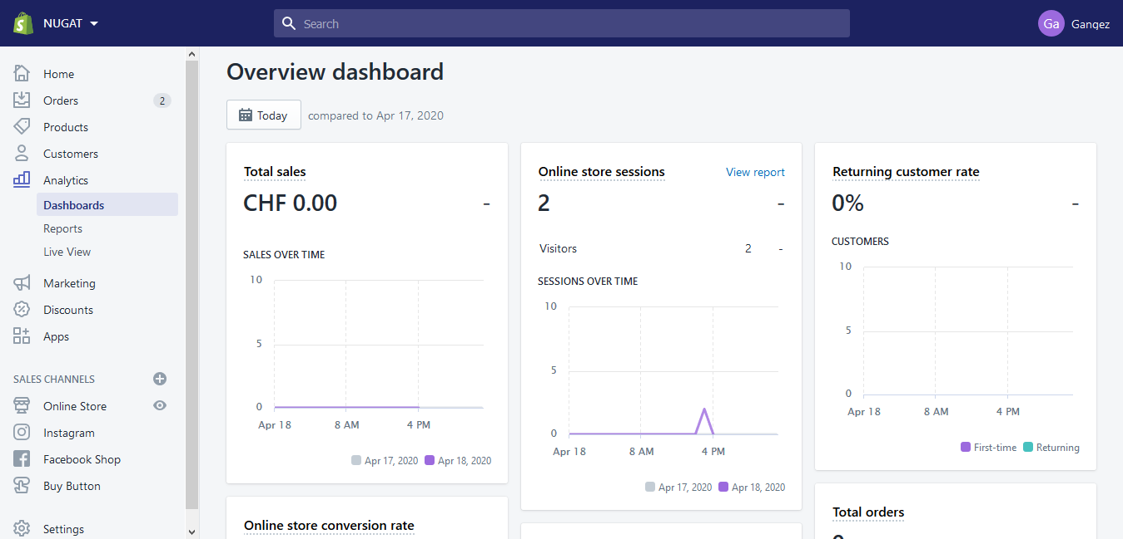

**Fig 5.21 Dashboard Page**

1. **Reports**

A Report is a document which contains data in an organized tabular or graphical format prepared for a certain period of time.

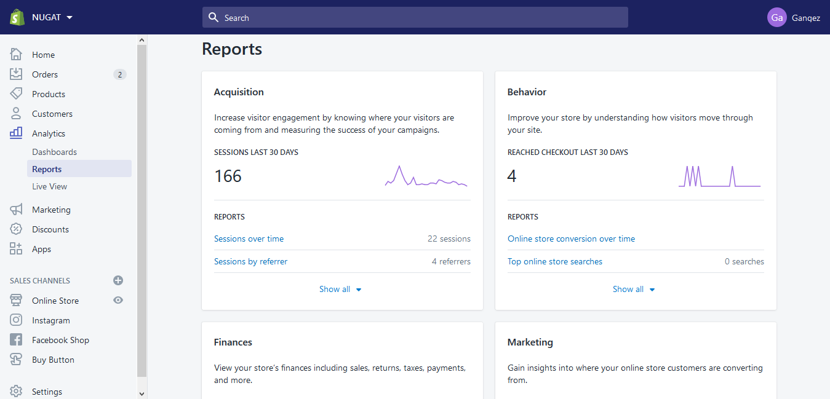

**Fig 5.22 Reports Page**

**(c) Live-View**

Live View gives you a real-time view of the activity on your store. Live View includes a world map to show you where the activity on your store is coming from.

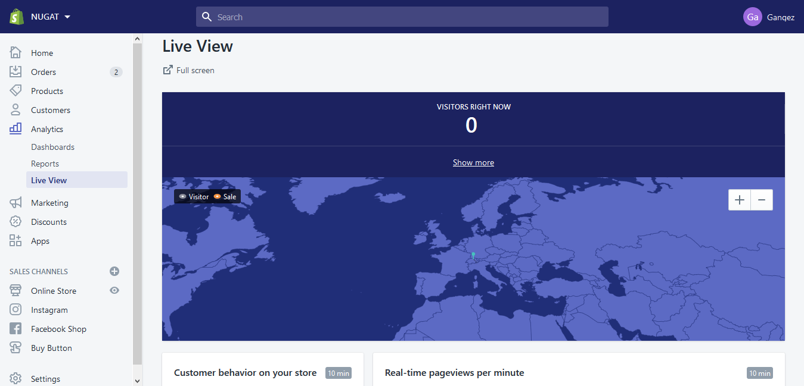

**Fig 5.23 Live-View**

**5.7.8 Marketing**

One platform to find and sell to the right shoppers, wherever they are. Find shoppers with content marketing and SEO tools.

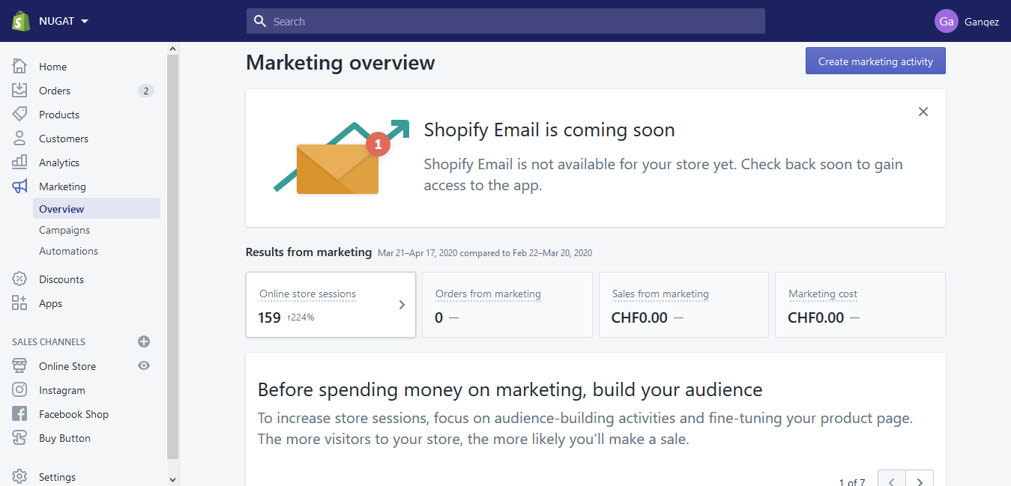

**Fig 5.24(a) Marketing Page**

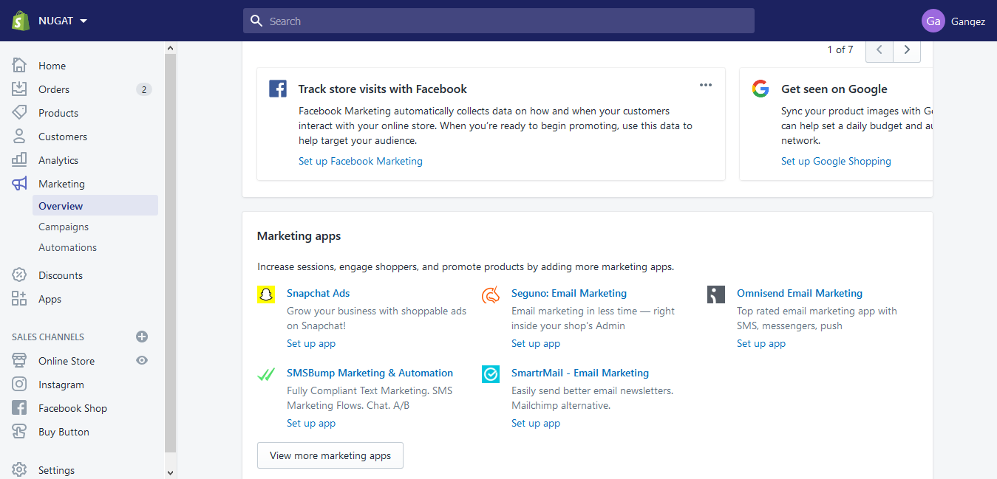

**Fig 5.25 (b) Marketing Page**

**5.7.9 Apps**

Shopify App Store downloads our Free and Paid Ecommerce plugins to grow your business and improve your Marketing, Sales and Social Media Strategy.

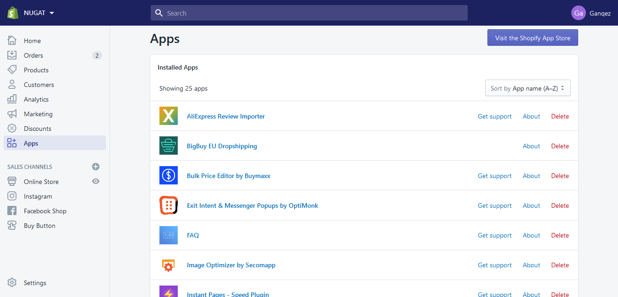

**Fig 5.26 Apps Page**

**5.7.10 Online Store**

1. **Themes**

Shopify Themes control the appearance of merchants’ online stores. Developers can use Shopify’s open-source Liquid templating language, along with standard HTML, CSS, and JavaScript, to create any look and feel their clients want.

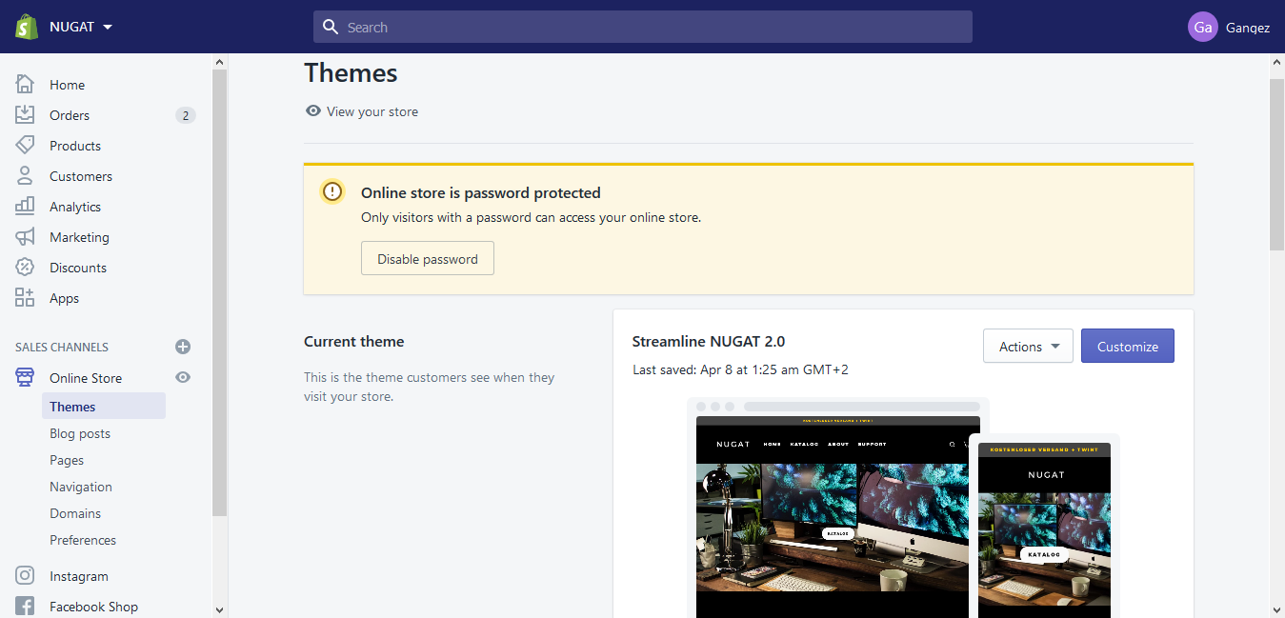

**Fig 5.27.1 Themes Page**

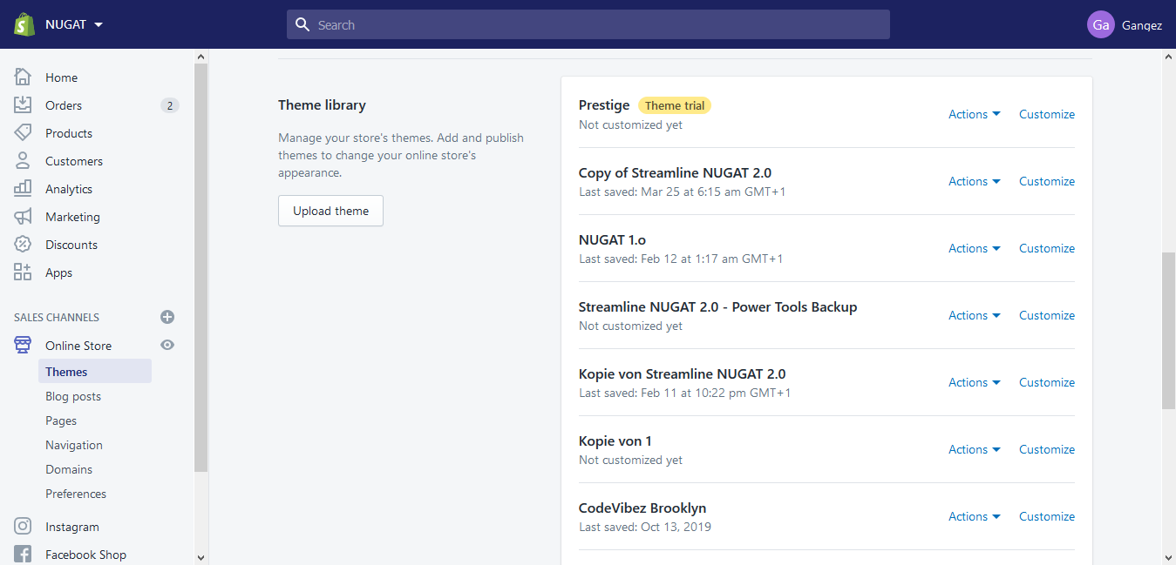

**Fig 5.27.2 Themes Page**

1. **Pages**

Web Pages contain information that rarely changes or that customers will reference often, like an "About Us" page or a "Contact Us" page.

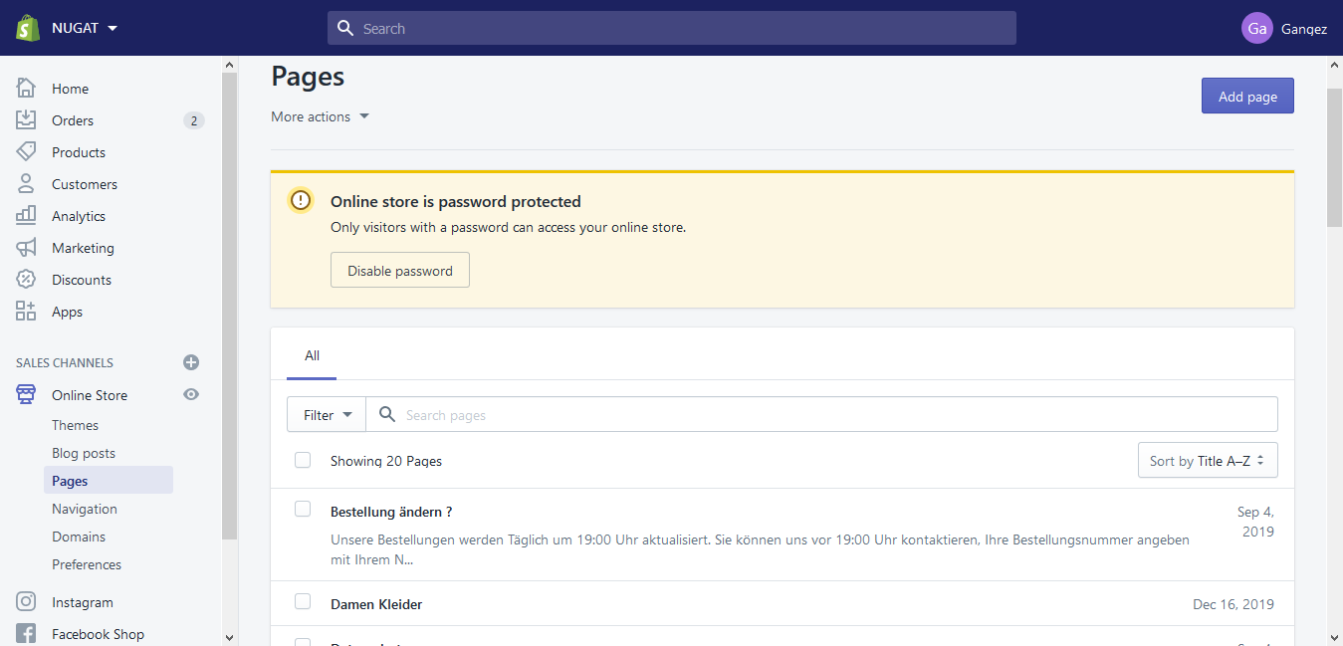

**Fig 5.27.3 Pages**

**(c)** **Navigations**

Navigations help your customers to find your products and information about your business. Online store has two default menus that appear on every page: the main menu and the footer menu.

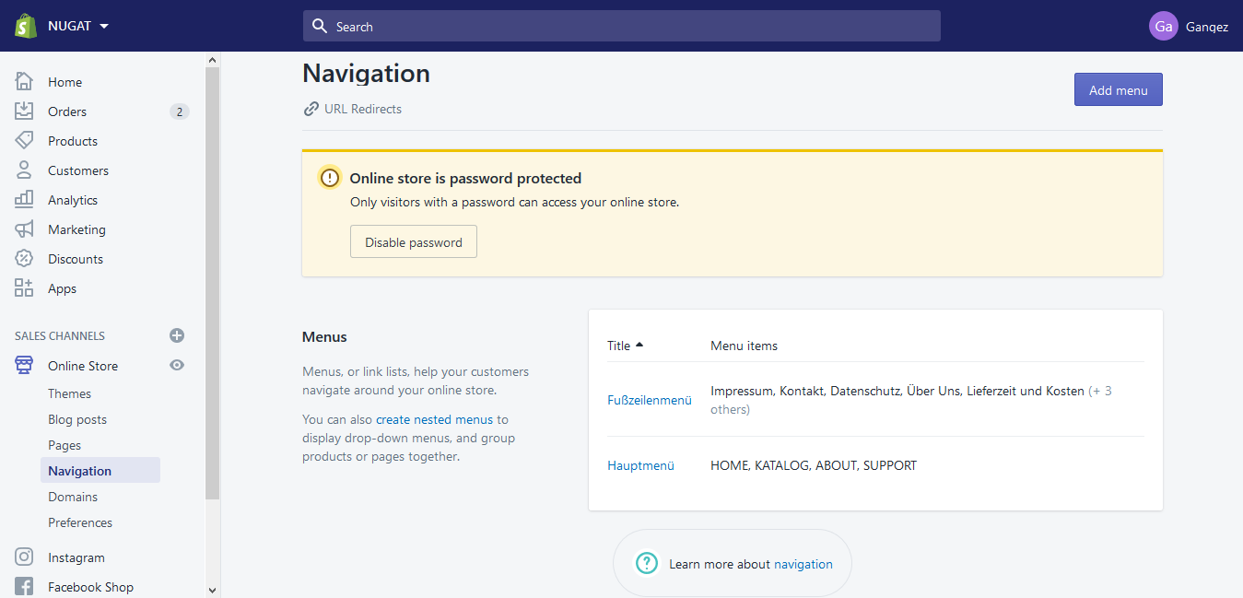

**Fig 5.27.4 Navigations**

**(d) Domains**

A Domain is the URL, or the website address, where your customers go to find your store online. Manage domain settings for online stores on the Domains page in your Shopify admin. By default, the primary domain looks like your-store-name.myshopify.com

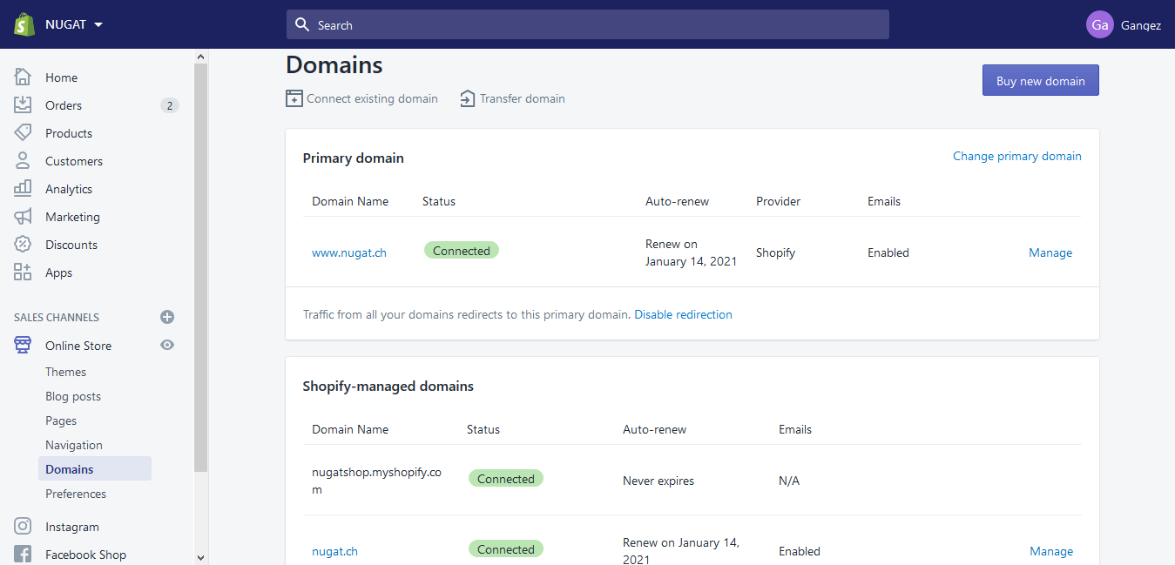

**Fig 5.27.5 Domain page**

**(e) Preferences**

You can edit the title and meta description of your online store, add tracking codes, or enable a password page or checkout protection on the Preferences page.

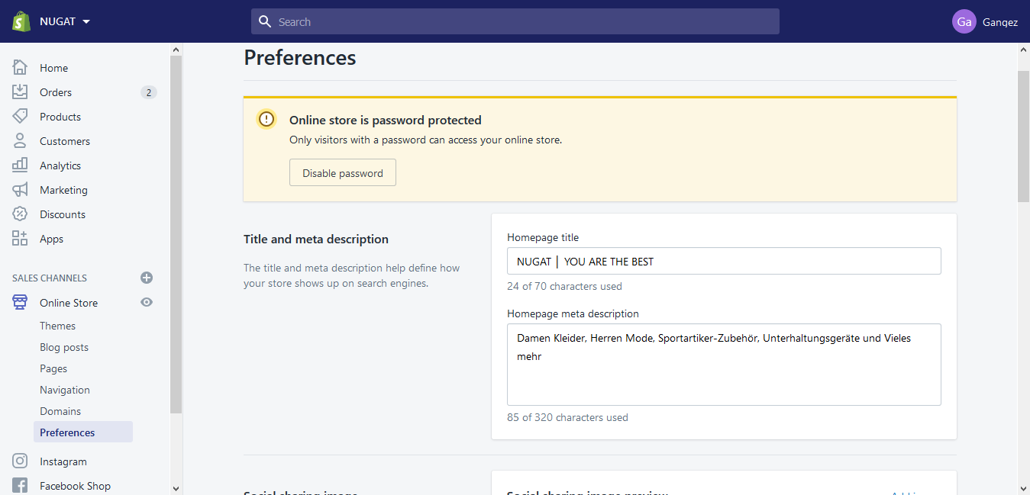

**Fig 5.27.6 Preferences**

**5.7.11 Settings**

Many more Advanced settings are available in this section.

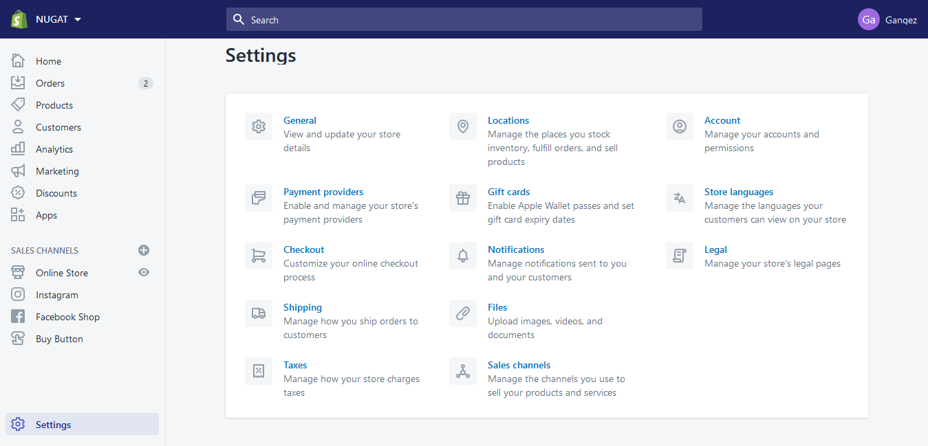

**Fig 5.28 Settings page**

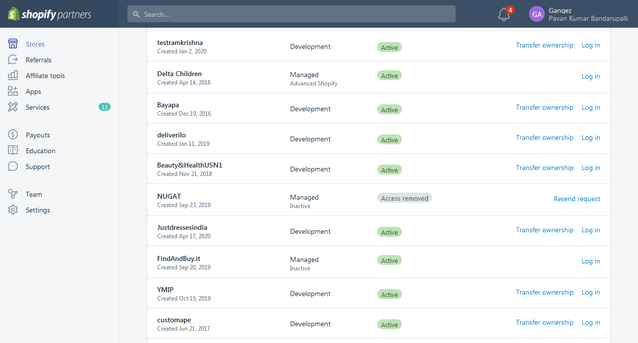

**Fig 5.29 Website Status Page**

**MOM & KIDSN**

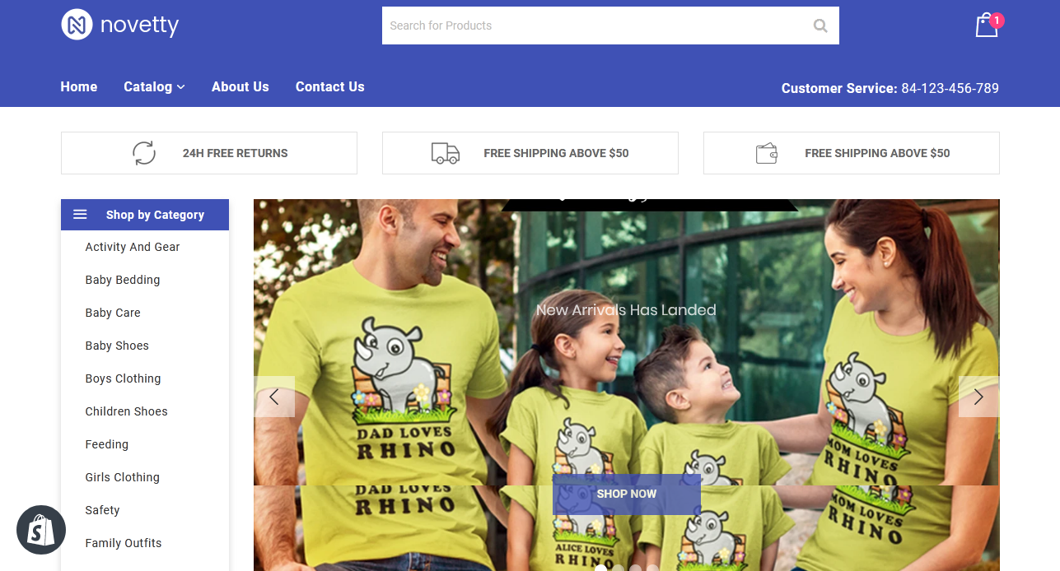

**Fig 5.30 Home Page**

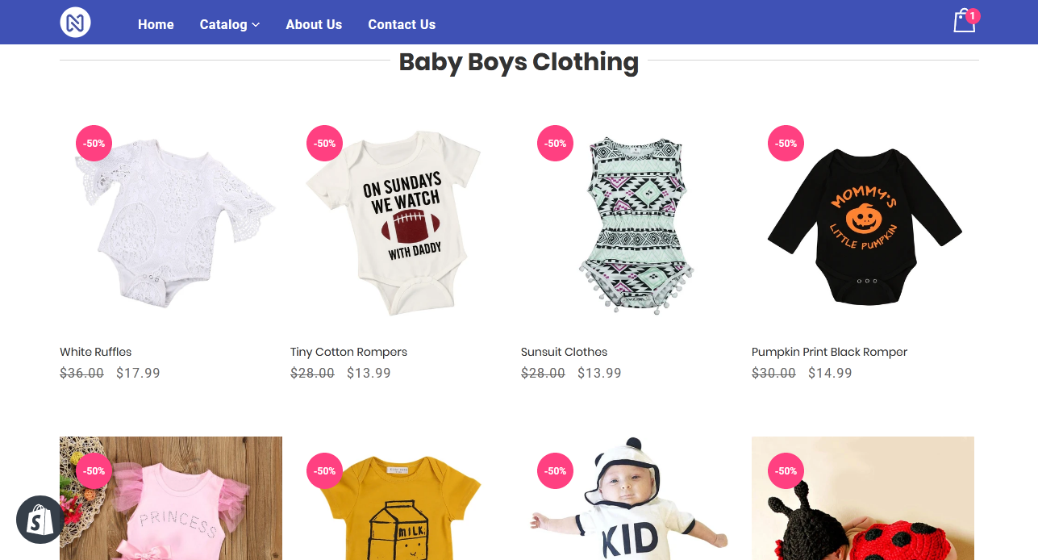

**Fig 5.31 Collections**

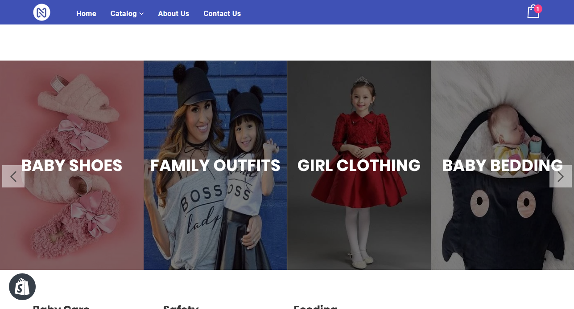

**Fig 5.32 Slideshow**

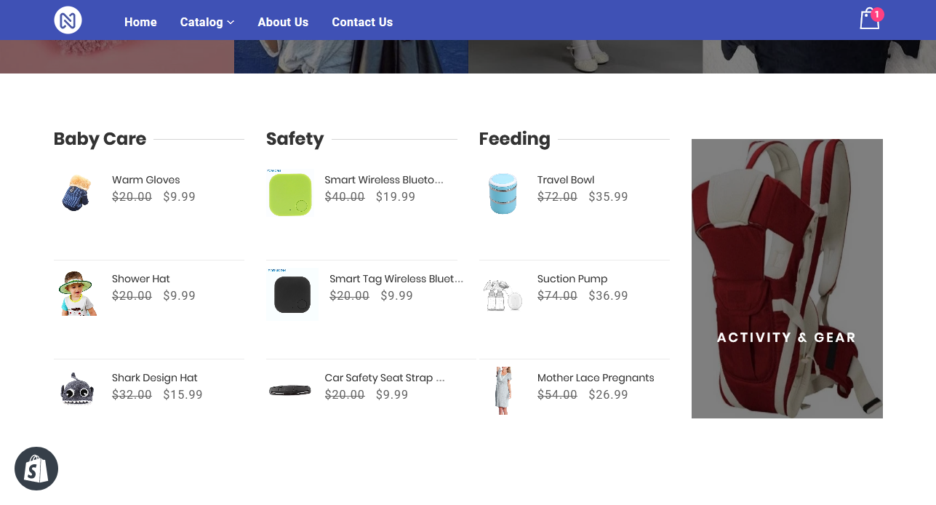

**Fig 5.33 Varieties of Products**

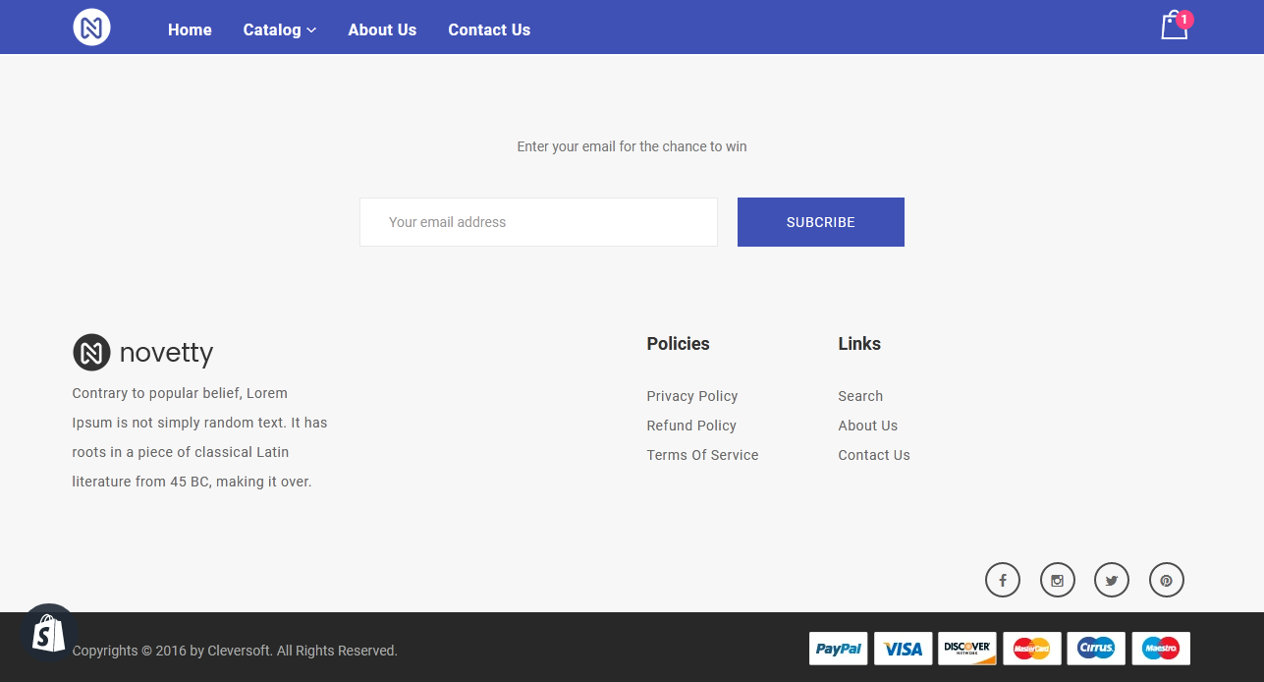

**Fig 5.34 Footer Section**

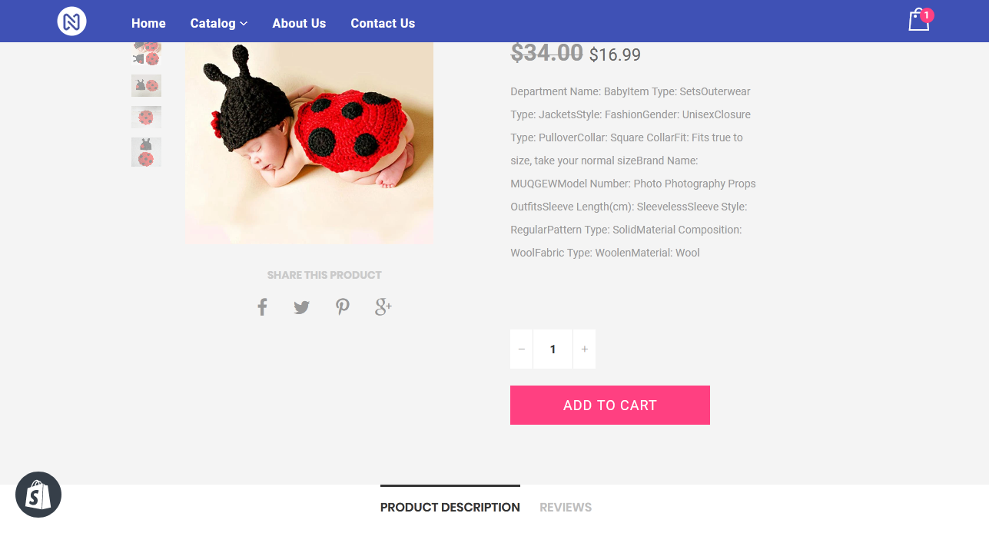

**Fig 5.35 Adding to Cart**

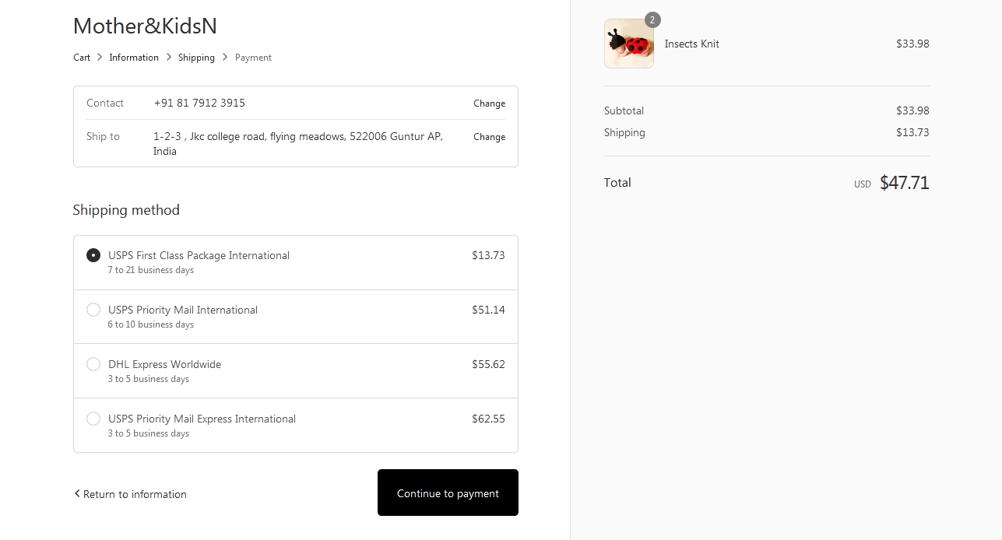

**Fig 5.36 Cart Page**

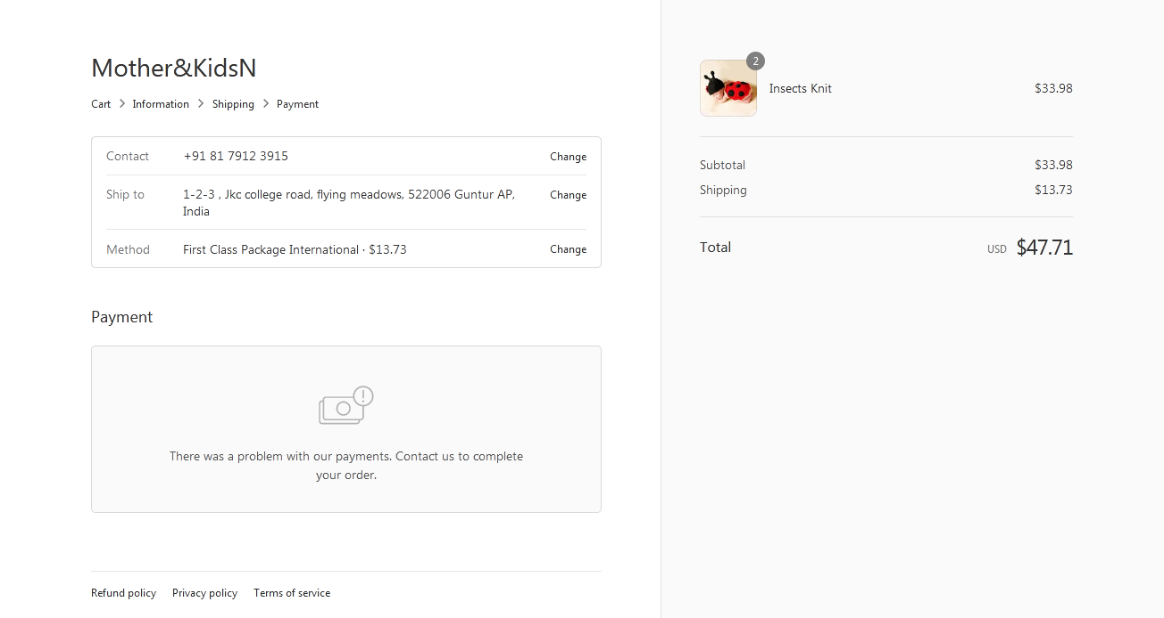

**Fig 5.37 Checkout Page**

**CHAPTER - 6**

**TESTING**

# 

# 6.TESTING

### 6.1 Software Testing

Software testing is the process of validating and verifying that a software application meets the technical requirements which are involved in its design and development. It is also used to uncover any defects/bugs that exist in the application. It assures the quality of the software. There are many types of testing software viz., manual testing, unit testing, black box testing, performance testing, stress testing, regression testing, white box testing etc. Among these performance testing and load testing are the most important one for an android application and next sections deal with some of these types.

### 6.2 Black box Testing

Black box testing treats the software as a "black box"—without any knowledge of internal implementation. Black box testing methods include equivalence partitioning, boundary value analysis, all-pairs testing, fuzz testing, model-based testing, traceability matrix, exploratory testing and specification-based testing.

### 6.3 White box Testing

White box testing is when the tester has access to the internal data structures and algorithms including the code that implement these.

### 6.4 Performance Testing

Performance testing is executed to determine how fast a system or sub-system performs under a particular workload. It can also serve to validate and verify other quality attributes of the system such as scalability, reliability and resource usage.

### 6.5 Load Testing

Load testing is primarily concerned with testing that can continue to operate under specific load, whether that is large quantities of data or a large number of users.

### 6.6 Manual Testing

Manual Testing is the process of manually testing software for defects. Functionality of this application is manually tested to ensure the correctness. Few examples of test cases for Manual Testing are discussed later in this chapter.

#### Test Case 1

|  |  |
| --- | --- |
| Test Case Name | Empty login fields testing |
| Description | In the login screen if the username and password fields are empty |
| Output | Login fails showing an alert box asking to enter username and password. |

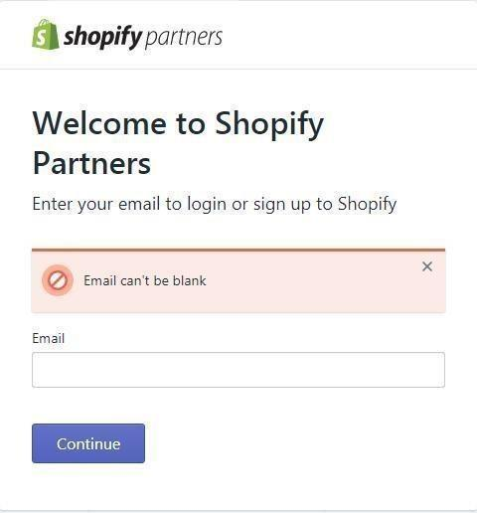

**Fig 6.1 Test Case for Empty Login Fields**

#### Test Case 2

|  |  |
| --- | --- |
| Test case Name | Wrong login fields Testing |
| Description | A unique username and password are set by the administrator. On entering wrong username or password gives. |
| Output | Login fails showing an alert box username or password incorrect. |

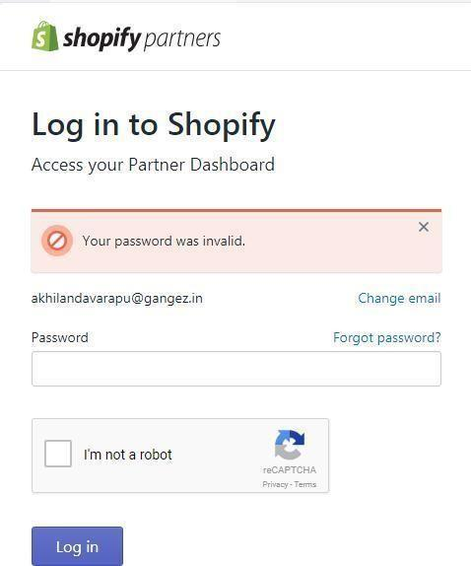

**Fig 6.2 Test Case for Wrong Login Fields**

**CHAPTER - 7**

**RESULTS & CHALLENGES**

## 7. RESULTS AND CHALLENGES

### 7.1 Results

The theme developed can be used by various industries to develop their online stores. All the features needed to develop the store will be in the customization dashboard, the store owner need not touch the code. Also, the customization can be done in less time by the store owner.

### 7.2 Challenges

* Understanding the client requirements was one of the crucial tasks of the whole project.
* Graphic User Interface (GUI) design was a difficult task as there are many types of Android devices and web platforms with varying screen size and resolutions unlike iPhone, Tablet, Nexus, Android, and Laptop etc.
* Implementing themes based on customer satisfaction is a challenging task.

**CHAPTER-8**

**CONCLUSION & FUTURE WORK**

## 8.CONCLUSION

### 8.1 Conclusion

In comparison to the other e-commerce store platforms Shopify has a greater demand in the market because of its user-friendly features and easily customizable nature. It is a marketing research that users have moved to Shopify from over 30 platforms and services including big commerce, Magneto, Amazon web store and 3D cart.

### 8.2 Scope for future work

E-Commerce is the current trend in the contemporary world. With the growing use of technology online shopping can be done at ease and hence the demand for online websites has been increasing tremendously. Shopify is the right platform to meet this growing demand where the customer can himself create his own store with a few clicks.

### 8.3 Limitations

* Content management.
* We cannot use java script in the schema.
* Product search and filtering.
* International Retail and localization.
* Multi store management.
* Locked checkout functionality.

## BIBLIOGRAPHY

* Liquid Basics -[https://help.shopify.com/themes/liquid/basics.](https://help.shopify.com/themes/liquid/basics)
* Theme Development[-https://help.shopify.com/themes/development.](https://help.shopify.com/themes/development)
* Liquid Cheat sheet-[https://www.shopify.in/partners/shopify-cheat-sheet.](https://www.shopify.in/partners/shopify-cheat-sheet)
* HTML, CSS and JS -[https://www.w3schools.com/.](https://www.w3schools.com/)
* Wikipedia -<https://en.wikipedia.org/wiki/Shopify>
* Liquid Basics [-https://shopify.github.io/liquid/](https://shopify.github.io/liquid/)
* Slate Tool :<https://shopify.github.io/slate/>
* Theme Kit Tool :<https://shopify.github.io/themekit/>
* Shopify help documentation :<https://help.shopify.com/>
* Git hub Liquid :<https://github.com/Shopify/liquid/wiki>
* Shopify Community :<https://ecommerce.shopify.com/>
* Shopify cheat sheet :<https://www.shopify.in/partners/shopify-cheat-sheet>
* Responsive design :[https://responsivedesign.is/guidelines/flexible-grid-based-](https://responsivedesign.is/guidelines/flexible-grid-based-layouts/) layouts